Chile’s desert dumping ground for fast fashion leftovers

Chile’s Atacama, the driest desert in the world, is increasingly suffering from pollution caused by fast fashion.
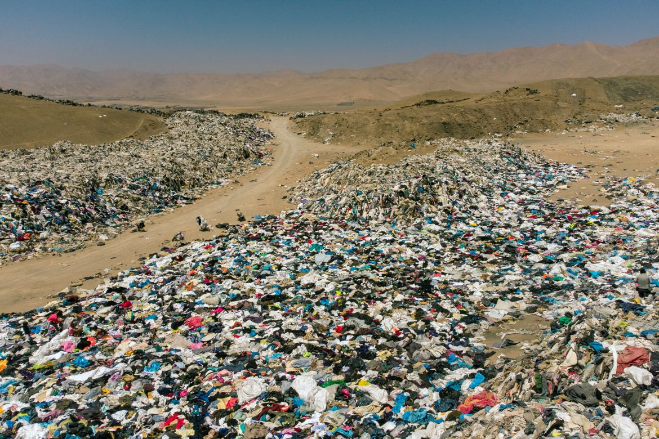
Used clothes discarded in the Atacama Desert, in Alto Hospicio, Iquique, Chile. [Martin Bernetti/AFP]
Published On 8 Nov 20218 Nov 2021
A mountain of discarded clothing, including Christmas sweaters and ski boots, cuts a strange sight in Chile’s Atacama, the driest desert in the world, which is increasingly suffering from pollution created by fast fashion.
The social effect of rampant consumerism in the clothing industry – such as child labour in factories or derisory wages – is well-known, but the disastrous effect on the environment is less publicised.
Chile has long been a hub of second-hand and unsold clothing, made in China or Bangladesh and passing through Europe, Asia or the United States before arriving in Chile, where it is resold around Latin America.
Some 59,000 tonnes of clothing arrive each year at the Iquique port in the Alto Hospicio free zone in northern Chile.
Clothing merchants from the capital Santiago, 1,800km (1,100 miles) to the south, buy some, while much is smuggled out to other Latin American countries. But at least 39,000 tonnes that cannot be sold end up in rubbish dumps in the desert.
“This clothing arrives from all over the world,” Alex Carreno, a former employee in the port’s import area, told the AFP news agency.
“What is not sold to Santiago nor sent to other countries stays in the free zone” as no one pays the necessary tariffs to take it away.
“The problem is that the clothing is not biodegradable and has chemical products, so it is not accepted in the municipal landfills,” said Franklin Zepeda, the founder of EcoFibra, a company that makes insulation panels using discarded clothing.
“I wanted to stop being the problem and start being the solution,” he told AFP about the firm he created in 2018.

Water waste
According to a 2019 UN report, global clothing production doubled between 2000 and 2014, and the industry is “responsible for 20 percent of total water waste on a global level”.

Sign up for Al Jazeera

Americas Coverage Newsletter

US politics, Canada’s multiculturalism, South America’s geopolitical rise—we bring you the stories that matter.
Sign up

By signing up, you agree to our Privacy Policy

To make a single pair of jeans requires 7,500 litres (2,000 gallons) of water.
The same report said clothing and footwear manufacturing contributes 8 percent of global greenhouse gases, and that “every second, an amount of textiles equivalent to a garbage truck is buried or burned”.
Whether the clothing piles are left out in the open or buried underground, they pollute the environment, releasing pollutants into the air or underground water channels.
Clothing, either synthetic or treated with chemicals, can take 200 years to biodegrade and is as toxic as discarded tyres or plastic materials.
Chile, the richest country in South America, is known for the voracious consumerism of its inhabitants.
Things are changing, though, according to Rosario Hevia, who opened a store to recycle children’s clothes before founding in 2019 Ecocitex, a company that creates yarn from pieces of discarded textiles and clothing in a poor state. The process uses neither water nor chemicals.
“For many years we consumed, and no one seemed to care that more and more textile waste was being generated,” she said.
“But now, people are starting to question themselves.”
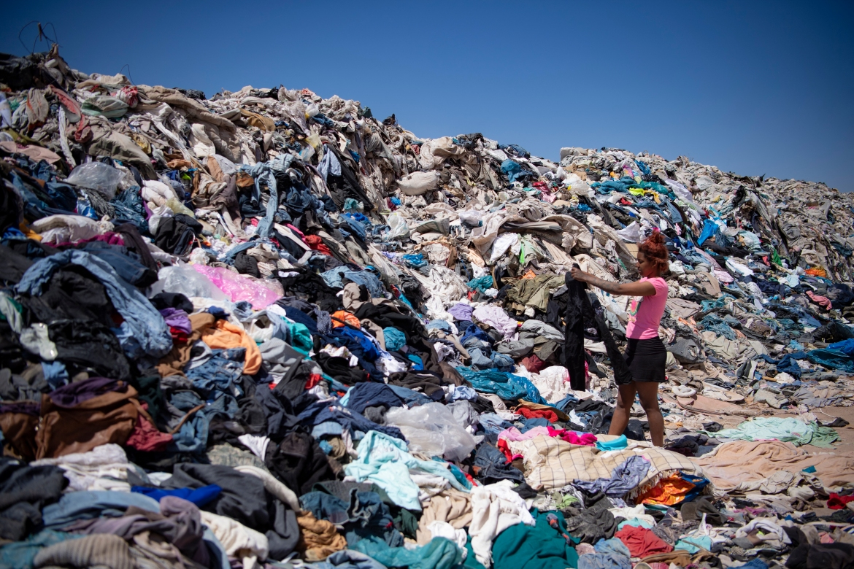
Women search for used clothes amid tonnes discarded in the Atacama Desert. Some 59,000 tonnes of clothing arrive each year at the Iquique port in the Alto Hospicio free zone in northern Chile. [Martin Bernetti/AFP]
Advertisement
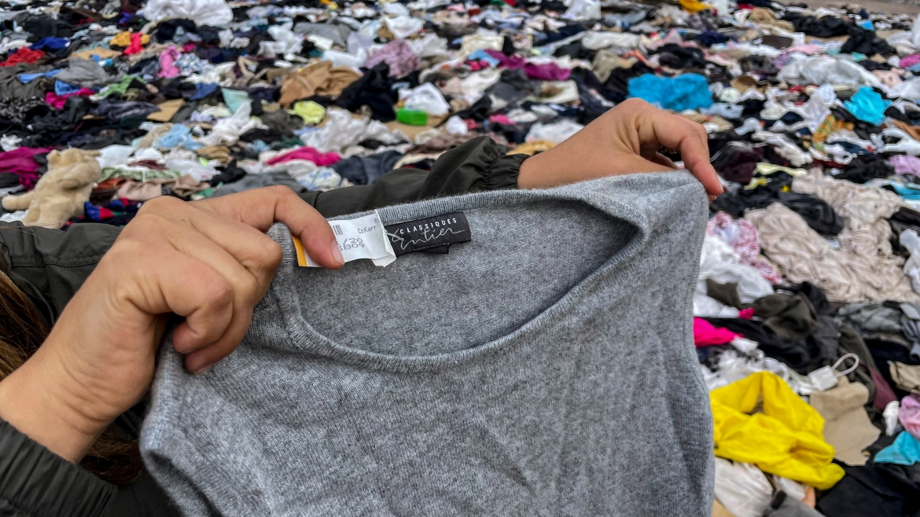
The textile industry in Chile will be included in the law of Extended Responsibility of the Producer (REP), forcing clothes and textiles importers to take charge of the waste they generate. [Martin Bernetti/AFP]
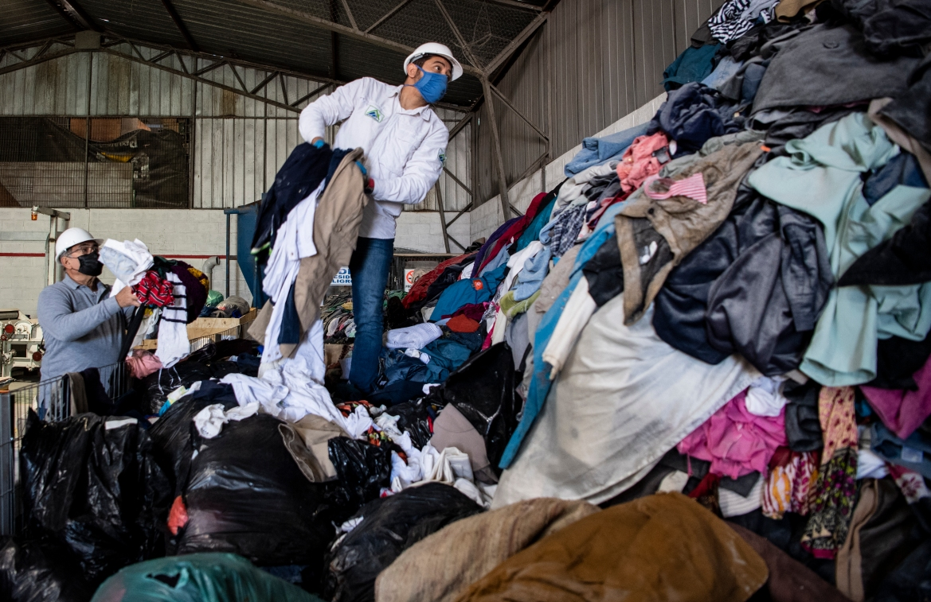
Men work at a factory that recycles used clothes discarded in the Atacama Desert for wooden isolation panels for the walls of social housing. [Martin Bernetti/AFP]
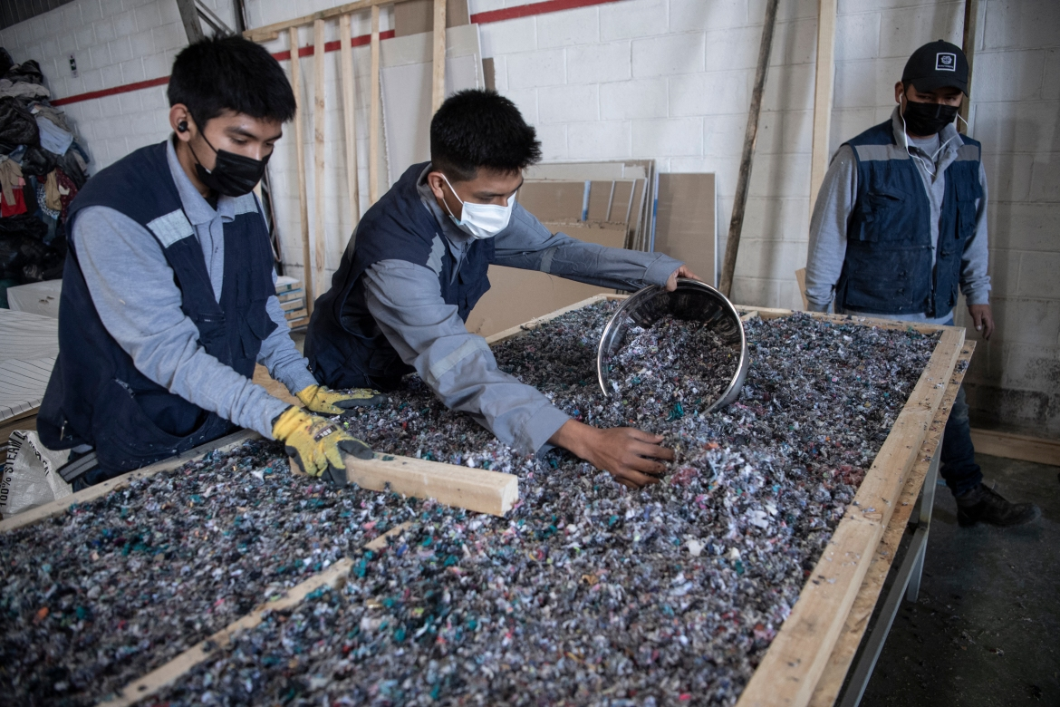
Men work at a factory that recycles used clothes discarded in the Atacama Desert. [Martin Bernetti/AFP]
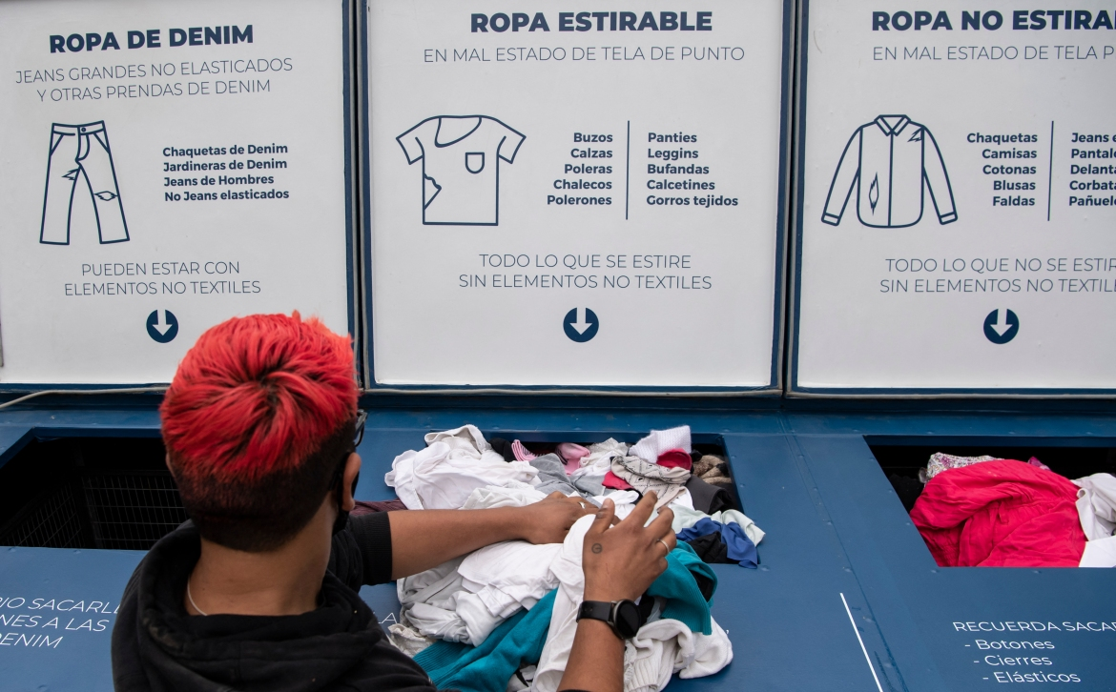
A man discards used clothes at a container of the Ecotex ecologic yarn factory in Santiago. [Martin Bernetti/AFP]
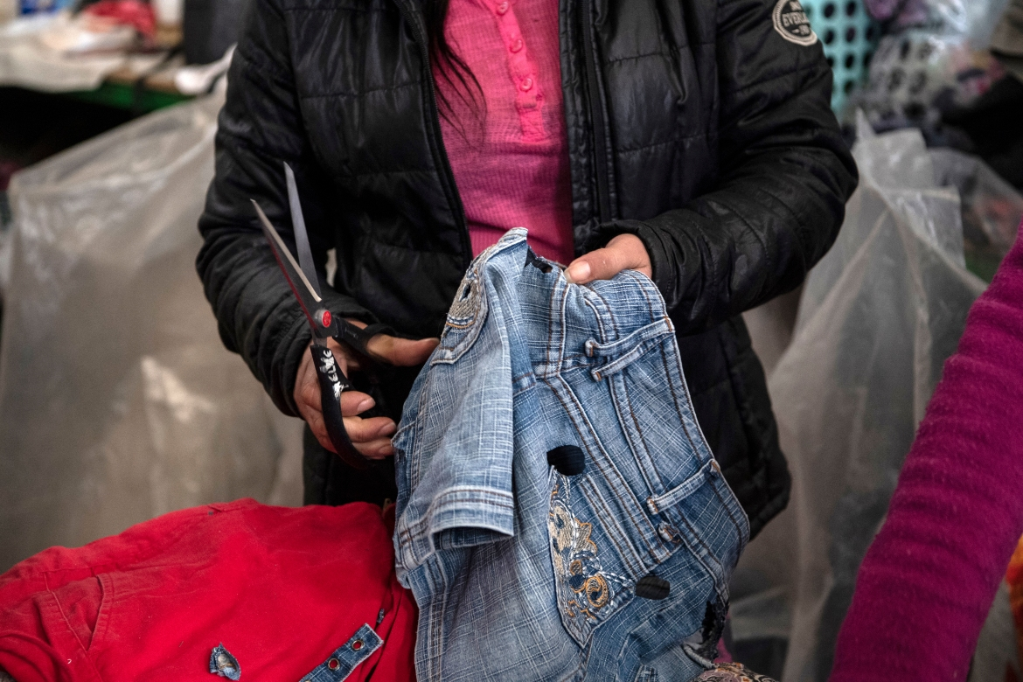
A worker rips metal buttons off a pair of jeans at a recycling factory. [Martin Bernetti/AFP]
Advertisement
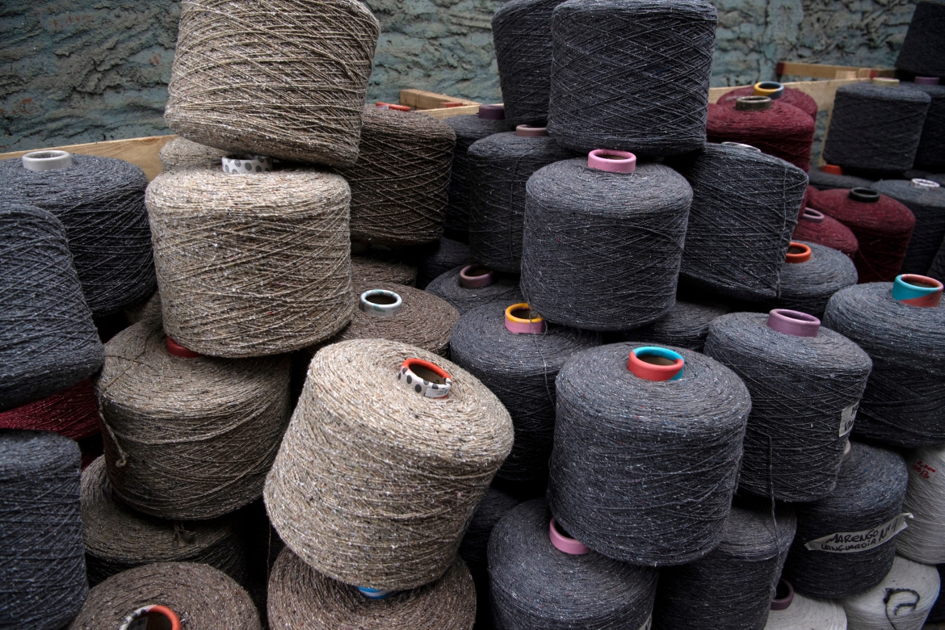
Ecologic yarns made of used clothes at the Ecotex factory. [Martin Bernetti/AFP]
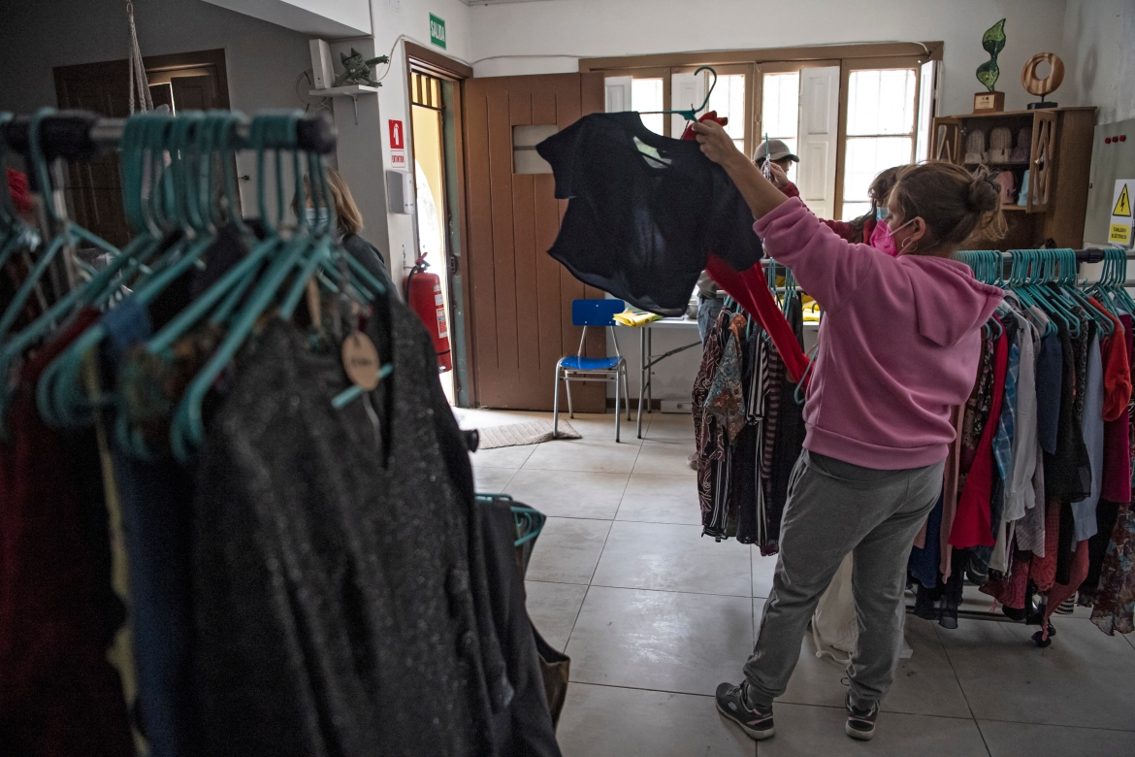
A woman shops for used clothes at the Ecotex ecologic yarn factory. [Martin Bernetti/AFP]
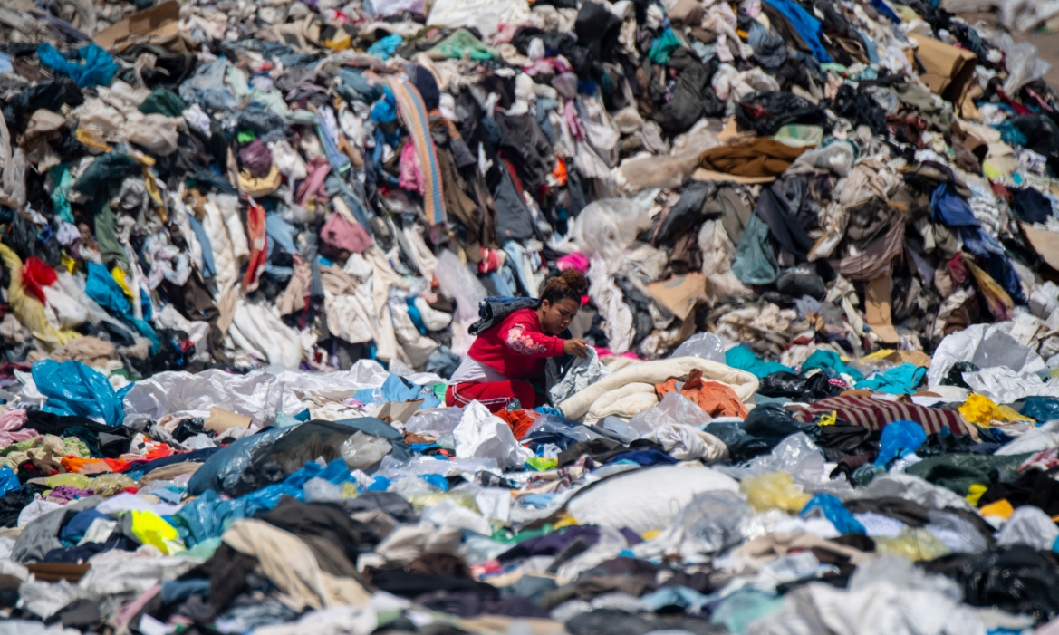
A woman searches for used clothes amid tonnes discarded in the Atacama Desert. Clothing, either synthetic or treated with chemicals, can take 200 years to biodegrade and is as toxic as discarded tyres or plastic materials. [Martin Bernetti/AFP]

