Sustainability in the Fashion Industry: How To Be A Sustainable Fashion Brand
31 May 2022 | Sustainability | Alicia Thew | Leave a comment
Sustainable fashion refers to clothing that is designed, produced, distributed, and used in a way that has minimal impact on the planet – and it’s arguably one of the biggest issues facing the fashion industry right now. If you’re looking to understand the environmental impact of the global fashion industry, and the solutions to make fashion more sustainable, then keep reading!
The fashion industry has seen spectacular growth over the past few decades, with statistics showing that the industry could increase in size by 8% from 2019 to 2022. While the sector is booming, it is causing a multitude of environmental impacts, accounting for roughly 10% of global carbon dioxide emissions.
The fast-paced and multifaceted nature of the fashion industry may leave some fashion brands not knowing where to start on their sustainability journey. To know how brands can become sustainable fashion brands, we need to first look at where the largest environmental impacts within the industry are coming from.

The Environmental Impacts of the Global Fashion Industry
Over 70% of the total greenhouse gas emissions generated from the apparel industry are related to raw material production, preparations, and processing, which are energy-intensive processes. The remaining 30% of greenhouse gas emissions are associated with the transportation, packaging, retail operations, and consumer use and disposal of garments.
In addition to the greenhouse gas emissions, the fashion industry also uses a huge volume of water, contributes significantly to water pollution, and produces a lot of waste. Recent estimates put the annual volume of water and waste for the industry at 79 trillion litres and more than 92 million tonnes of waste.
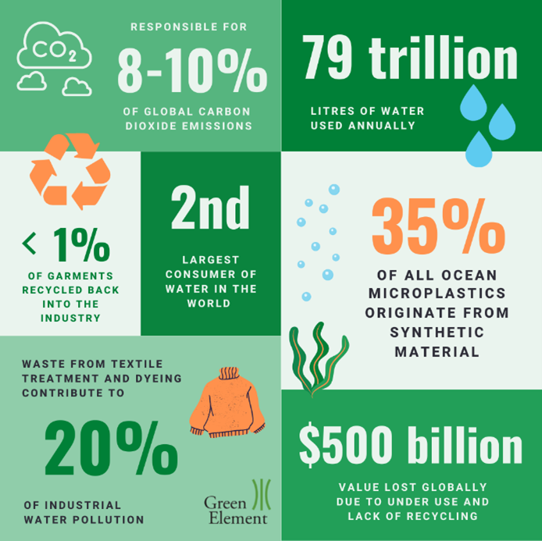
The waste from textile treatment and dyeing alone contributes to approximately 20% of industrial water pollution and 35% of all ocean microplastics originate from synthetic materials. Meanwhile, globally more than $500 billion of value is lost to the underuse and lack of recycling of garments, with less than 1% of garments recycled back into the industry.

What is Sustainable Fashion?
Sustainable fashion refers to clothing that is designed, produced, distributed, and used in a way that is environmentally and socially responsible. To become a sustainable fashion brand, the major stages in the lifecycle of any garment must be evaluated, including material extraction and processing, material and garment production, distribution and shipping, consumer use, and disposal, considering where and how you can interject to develop more sustainable operations.
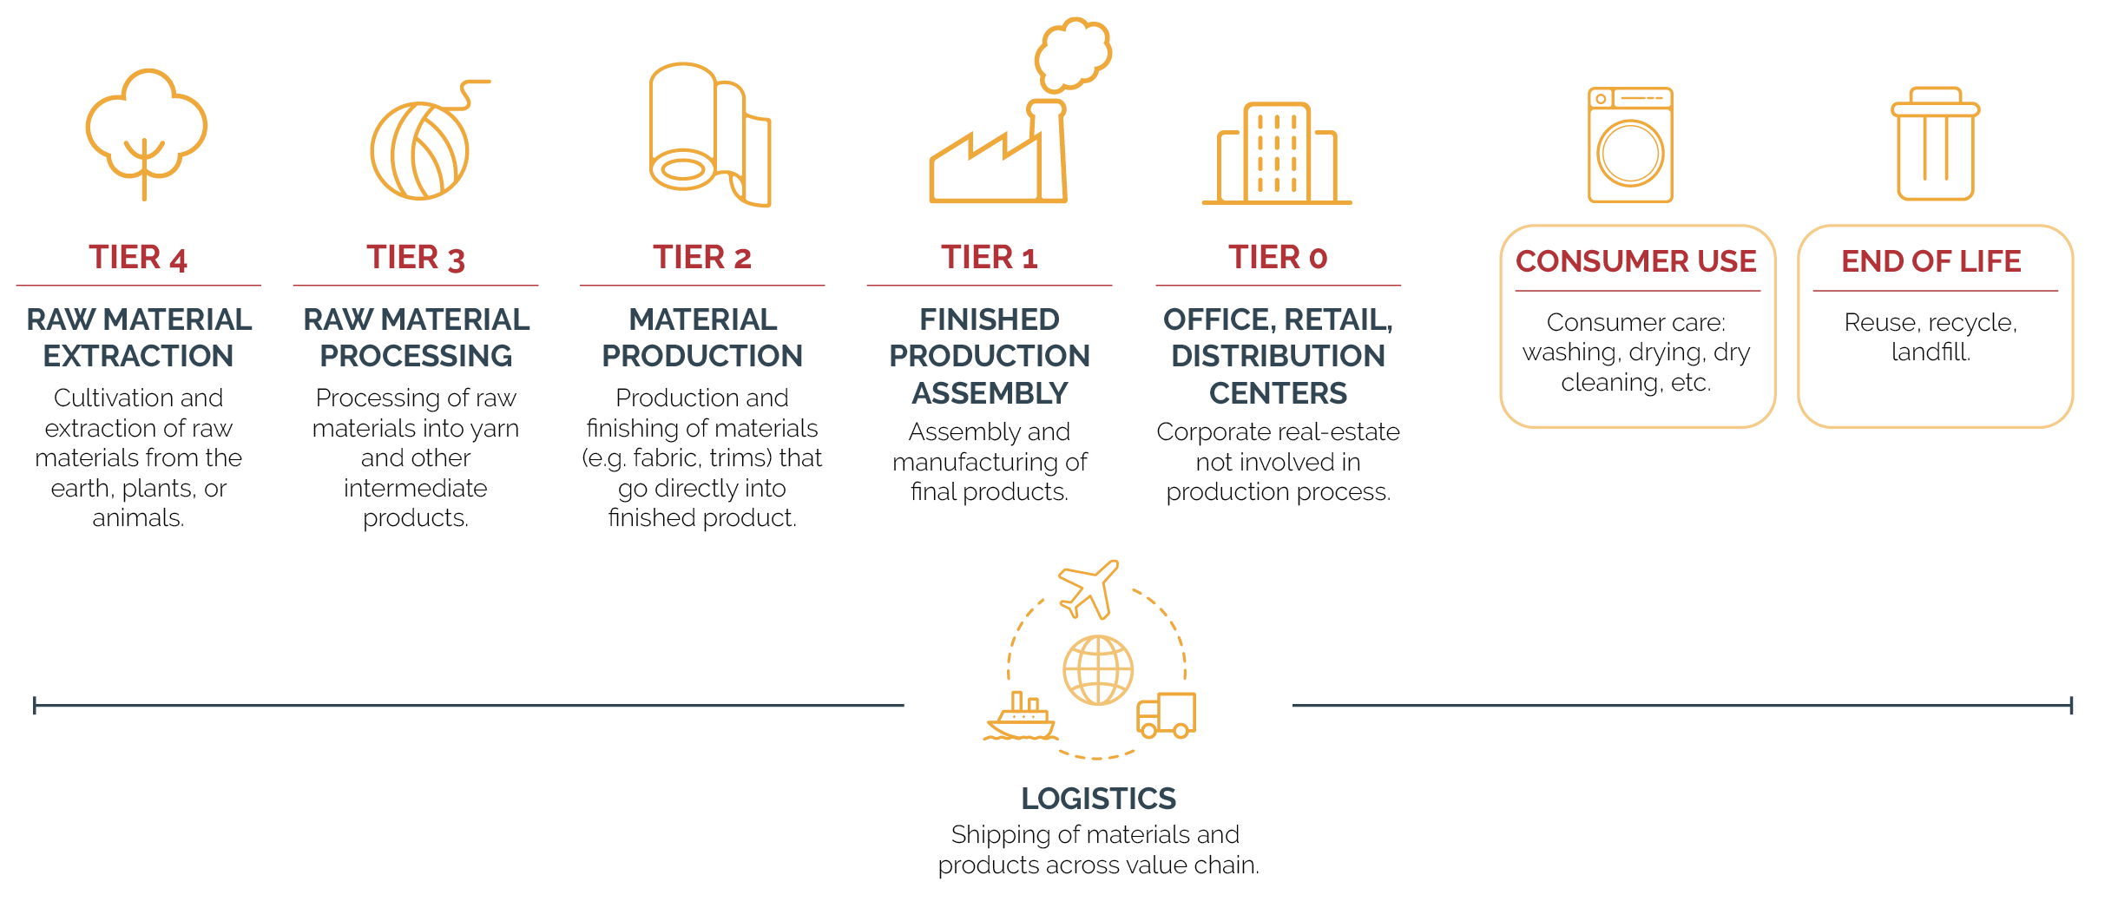
Source: Science-Based Targets Initiative. Apparel and Footwear Sector: Science-Based Targets Guidance
The development of new systems and processes throughout the industry offers potential for change. Within these major stages in the product life cycle, various processes and systems can be implemented to reduce environmental impact:
- Innovative fibres and fabrics
- Agricultural sustainability
- Efficient machinery
- Technological advances in materials processing
- Freight decarbonisation
- Lower-impact packaging
- Consumer education and advice
- Repair, re-use, recycle

Material Choices
Natural materials like cotton, wool, and silk have been used to make clothing for centuries. Synthetic fibres on the other hand, such as polyester, are much newer and originate from the transformation of inorganic polymers into fibres. Newer still are semi-synthetic fabrics such as viscose and other cellulose-based textiles which originate from plant-based fibres that undergo synthetic chemical processing.
Whether synthetics or naturals have lower environmental impacts depends on the sourcing of raw materials, the method of production, and whether the impacts are measured over the entire lifetime of the garments. Sourcing of materials should be taken on a case-by-case basis with a full life cycle analysis approach. For example, organic farming can have positive environmental impacts compared to conventional farming by reducing the amount of pesticides and fertilisers used on the land which have negative consequences for eutrophication, acidification, and soil health.

Synthetic Fibres
Clothing represents more than 60% of textiles used globally. Of those textiles, a staggering 60% of the material used in clothing is polyester. Polyester is a synthetic material made from fossil fuels, specifically petroleum, making it a carbon-intensive textile for use in clothing.
Polyester can instead be made from 100% recycled plastic bottles and can be manufactured from 100% renewable energy, cutting down the greenhouse gases associated with raw materials and production. This has been demonstrated by sustainable clothing brand Patagonia; 88% of the polyester they use in clothing is now recycled. However, the viability of producing recycled plastics for use in clothing has been questioned owing to the complex mixtures of most plastics which are hard to recycle, and the practicality and sustainability of available plastics recycling techniques.
Furthermore, microplastics can still be shed from clothing made from recycled polyester. Micro-plastics are shed from garments during washing and release toxins into the environment which are bad for seal life. Microplastics are also ingested by marine fauna where they enter the food chain and accumulate; this also has potential risks for human health.
On the other hand, bio-based materials such as lyocell and modal can offer cellulose-based alternatives which do not rely on fossil fuel raw materials and do not shed microplastics.

Cellulose-based Fibres
Cellulose-based materials commonly used in clothing include viscose, lyocell, and modal fabrics. These materials are sourced from natural materials such as wood, bamboo, cotton, and seaweed, which undergo chemical processing to extract cellulose that can be spun into fibres.
Whilst bio-based materials are 100% biodegradable and compostable, they require land and water to grow crops as well as energy and chemicals for processing. However, some plants such as eucalyptus and bamboo are easy to grow without the use of fertilisers, pesticides, or irrigation. Meanwhile, the chemicals used in processing lyocell for example can be almost 100% recycled with hardly any chemical by-product.
Several brands are using bio-based materials including BAM and Allbirds. Devon-based BAM constructs their entire range of clothing from bamboo and organic cotton, without the use of enhanced irrigation or pesticides. Similarly, Allbirds aim to use only natural or recycled materials throughout their clothing and footwear, even developing new materials such as their own plant-based leather.

Agricultural Sustainability
The discussion around natural versus synthetic fibres used to make textiles is complex. There are problems associated with the raw materials used to make synthetic fibres, for example, fossil fuels, as well as the intense production processes and end of life.
However, natural fibres such as wool and cotton can also be produced in an unsustainable and unethical manner. This is dependent on the farming practices used including the use of land, water, fertilisers, and pesticides as well as animal welfare.

Wool
Wool is a diverse and durable fabric that is also natural and renewable, therefore it is popular for use in knitwear. It is also naturally breathable and odour repellent, reducing the number of times that garments need washing and reducing the energy required for garment care.
Some brands are suggesting only washing woollen clothing when stained or starting to smell. Despite this, it is the production of wool that has the greatest impact on the carbon footprint, water use, and land use of woollen garments.
Farming sheep for wool is a carbon-intensive process, largely owing to the methane (a greenhouse gas) produced by sheep as part of their digestive process. The reduction of methane produced by livestock has been modelled via feeding alternatives and manure management.
In addition to this, variation in the carbon footprint of wool can be found depending on where the wool is produced and the farming system used, for example, regenerative farming is more environmentally friendly. Regenerative farming practices can include tree planting, managed grazing, revegetation of waterways, erosion control, and improving soil health.
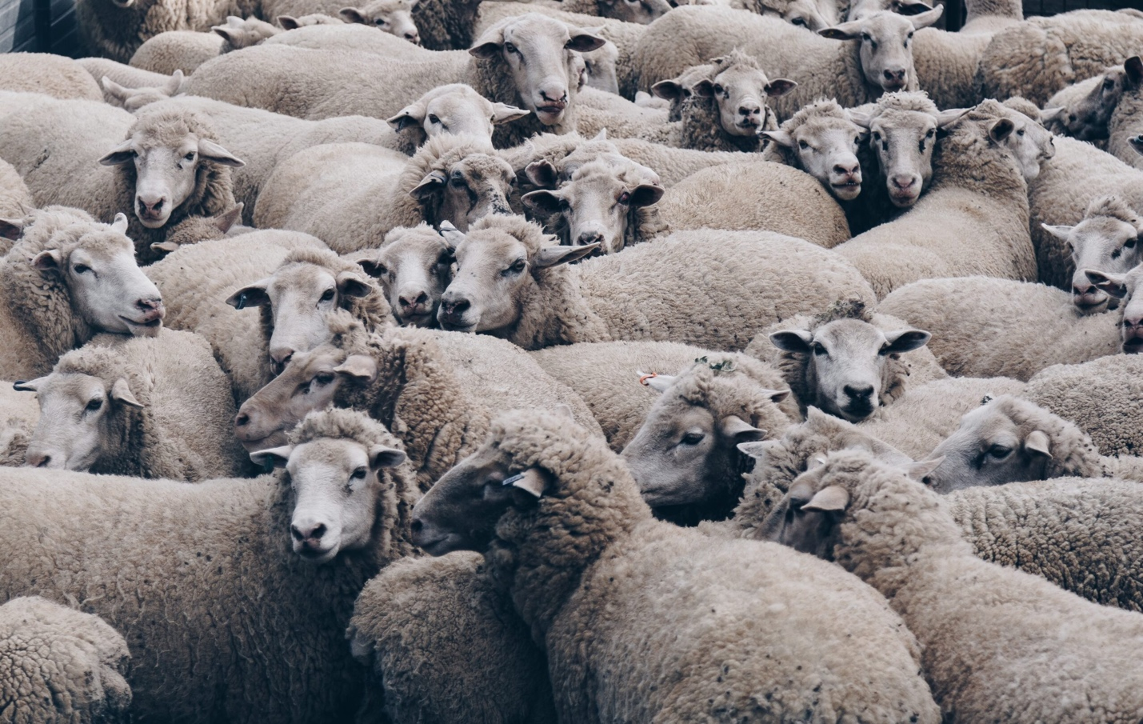
Source: Photo by Christopher Burns on Unsplash
Measuring the impact of wool, therefore, requires a complex life cycle analysis and consideration of the co-production of the sheep for wool and other products such as meat. This can lead to difficulties selecting the most appropriate allocation method for greenhouse gas emissions (a biophysical method being preferred) and result in further uncertainty over the true footprint of the wool being used.
Allbirds aim to source 100% of their merino wool from regenerative agriculture by 2025.
Choice of a wool producer is therefore critical when using wool for clothing. Designers of sustainable fashion brands should consider how the wool is sourced, as well as animal welfare and opportunities for using less carbon-intensive wool alternatives.

Cotton
Cotton is one of the most widely used fibres; it is estimated that approximately 30% of fibres used in the textile industry are cotton. However, there are many challenges associated with the production of cotton. Globally, just 40% of cotton is supplied by rainwater alone, the other 60% is irrigated with 3,644m³ of water required per tonne of cotton.
The inappropriate use of fertilisers and pesticides in unsustainable cotton production can have serious consequences for soil fertility and water sources. Cotton farming also affects soil health, depleting fertility, and biodiversity.
That being said, cotton can be grown in more sustainable ways. A 2020 study showed that organic cultivation combined with renewable energy sources can decrease eutrophication by 48%, acidification by 52%, and global warming potential by 70% compared to traditional farming. This is largely owing to the absence of pesticides and synthetic fertilisers.
Brands looking to make the switch can engage with standards such as the Organic Cotton Standard and the Global Organic Textile Standard. Other more affordable cotton alternatives include Better Cotton which requires farmers to meet the standards of the Better Cotton Initiative, including the adoption of efficient farming techniques and minimal use of fertilisers and pesticides.

Linen and Hemp
Being few of the oldest crops to be grown for clothing, hemp and linen have high yields, require no pesticides and fertilisers, and can rely on rainwater alone for irrigation.
A study comparing the carbon footprint of textiles used on UK clothing in 2009 found that linen has the lowest carbon footprint of all common fibre types compared in the study. Whilst both hemp and linen have been shown to have lower environmental impacts compared to other fibres, the feasibility of their expanded use in textiles (especially hemp) is untested and could be challenging owing to the amount of land required to grow crops.

Technological Advances in Material Processing and Efficient Machinery
Aside from producing the fabrics themselves, manufacturing can contribute to a large portion of greenhouse gas emissions.
Levi Strauss & Co estimated that approximately 40% of their total carbon footprint was owing to fabric production (knitting, dyeing, washing, etc.) and garment assembly (sewing together).
The Science Based Targets initiative recommends investing in renewable energy and energy-efficiency enhancements in collaboration with suppliers. Producing clothing using 100% renewable energy and cutting out fossil fuels significantly decreases the volume of greenhouse gases.
Machinery modifications for motor and air pressure and upgraded equipment, such as sewing machines, can increase the efficiency of sewing, spinning, weaving, and knitting.
Waste is also a problem in the manufacturing stage of clothing; efficient garment design and modern cutting techniques can reduce material waste. Increased energy and water and waste efficiency can have a big impact on sustainability and be financially beneficial to suppliers and designers.

Clothing Dye
Fabric dyeing is a key stage in garment manufacturing, but synthetic dyes have increased environmental pollution since their introduction. Azo dyes are the most used type of colorant due to their ease of use, cost-effectiveness, and colour fastness to light and water.
However, they are poorly biodegradable and can lead to mutations and carcinogenic effects in waterborne organisms and humans.
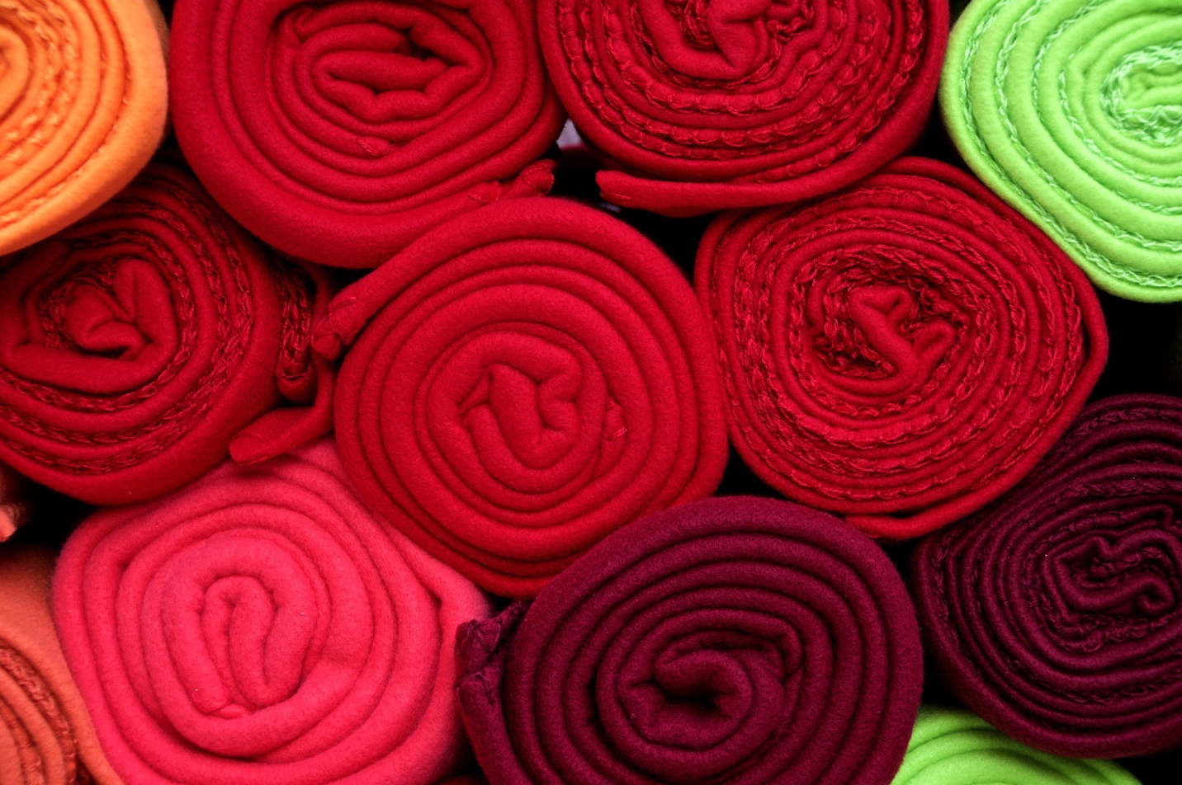
Source: PIRO4D on Pixabay
Natural dyes on the other hand are considered biodegradable and renewable and can therefore be considered a more sustainable alternative to synthetic dyes. Natural dyes can be extracted from plants, some animals, microorganisms, and minerals. Research and improvements in the quality of natural dyeing could be revolutionary to material processing, with some brands having already launched natural or eco-dyed ranges.
For some fabrics, such as modal, innovative dyeing techniques such as spin-dying can be used. The cellulose fibres are dyed before they are spun into individual fibres, one study reported results of 60% fewer greenhouse gas emissions and 50% less water required.
There are even lower impact methods of textile dyeing that can reduce energy, chemicals, and waste. Liposome-based technology involves the use of liposomes as a way of delivering dyes to textiles. The use of liposomes is more cost-effective and environmentally friendly compared to traditional methods because they are biodegradable and operate at lower temperatures.
Additionally, ultrasonic energy can be used to improve the transfer of dyes to fabrics, decreasing the temperature (therefore energy) and quantity of chemicals used.

Freight Decarbonisation
Whilst raw material sourcing and garment manufacturing make up the largest part of a garment’s environmental footprint, there are also opportunities within a brand’s own supply chain to improve sustainability. This can include the decarbonisation of freight by shifting away from carbon-intense modes such as air, towards sea and rail freight where possible.
Choice of a freight carrier, if using third-party hauliers, can impact greenhouse gas emissions per tonne shipped. Some hauliers such as Royal Mail, DPD, and UPS are decreasing their carbon intensity by integrating electric vehicles into their fleets. Whilst airlines with newer, more efficient aircraft can have lower carbon intensity per kilometre travelled. The movement towards electric vehicles and hydrogen as an alternative to fossil fuels will accelerate the decarbonisation of freighting goods.
Special attention to routing, vehicle and driving efficiency, fleet maintenance, reducing packaging, and limiting customer returns can all have a positive impact on the footprint of shipping.

Lower-impact Packaging
Increasing the content of recycled materials in packagings such as plastic poly bags and cardboard boxes can decrease your carbon footprint. However, the first step in reducing GHG emissions from packaging should be to reduce how much is used.
Online retailer Internet Fusion has eliminated 92 truckloads of excess packaging by using packaging technology provided by Sparck which efficiently packages items to minimise the use of void fillers and fibreboard. This also resulted in cost savings as shipping volumes were lowered and labour resources were freed-up.
Alternatives to plastics are also available such as water-soluble poly bags made using the Hydropol polymer from Aquapak. Poly bags made from Hydropol are marine safe and compostable and are already being used by Finisterre instead of regular plastic poly bags. However, whilst Hydropol poly bags offer a safer option for marine life, their whole environmental footprint must be considered.

Consumer Education and Circularity
Consumer use can have a significant impact on a brand’s carbon footprint.
Levi Strauss and H&M report between 18-34% of their company’s carbon footprint is down to consumers.
Consumer use includes the energy involved in the care of garments, primarily washing. Washing clothes uses energy, with the temperature that clothing is washed at affecting the amount of energy- used, and therefore GHG emissions per cycle. Washing at cooler temperatures decreases the environmental impact of consumer use.
The Science-based Targets Initiative advises commitment to change consumer behaviour (less frequent washing and drying), collaborating with other actors (such as detergent and washing machine brands) to increase efficiency, and shifting fabric types (to those that need less laundering). Coupling the use of low-maintenance fabrics with a strong customer message and clear care instructions can reduce the impact of consumer use.
Consumers also have a part to play at the end of life of clothing and the number of times it is worn. WRAP estimates that on average a garment’s life cycle is 2.2 years. This period can be extended by producing high-quality, durable garments designed in a classic style that can be adjusted, repaired, and washed multiple times. However, a change in customer mindset is also required to accept the benefits of moving away from ‘fast fashion’ and celebrate high-quality, sustainable clothing.
To learn more about adopting and promoting circularity in your business, read our recent blog: Making the Linear Circular: a short guide to the circular economy

What’s Next for Sustainable Fashion Brands?
The environmental impact of the fashion industry is multi-dimensional, and change is required throughout every stage of a garment’s lifecycle to make fashion sustainable. As the demand for clothing increases, materials producers, manufacturers, designers, and brands will need to invest in new technologies to minimise the consequences for the environment.
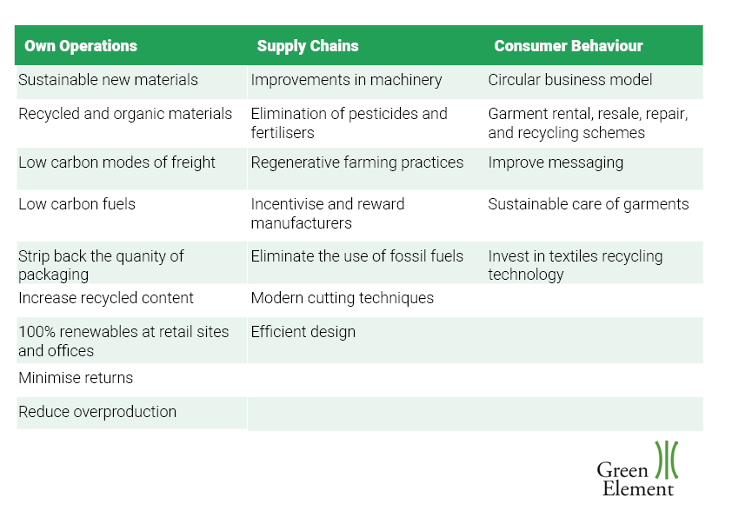
However, alongside innovative materials and processes, innovative thinking is also required from consumers to change the way and the amount we buy. The latter is in some ways a bigger challenge and leadership from the top down will be essential in bringing about change. When the leaders of the industry start to make and sell apparel in a sustainable, environmentally conscious way, there is hope for the rest of us.
If you are a fashion brand looking to become more sustainable, calculating your carbon footprint is a key step in getting to know your supply chain and your associated GHG emissions. Follow these first steps to begin your sustainable fashion journey:
- Map your supply chain to identify key suppliers to survey for environmental data such as energy, water, and waste
- Calculate your baseline carbon footprint and identify your carbon hotspots
- Set your science-based targets with the Science Based Targets Initiative
- Work within your business and collaborate with suppliers and hauliers to drive decarbonisation

