Bangladesh Is Burning And Sweatshops Are The Fuel
David Volodzko
Former Contributor
I am an editor at the technology and information company Brightwire.
Mar 5, 2019,01:33pm EST
This article is more than 4 years old.

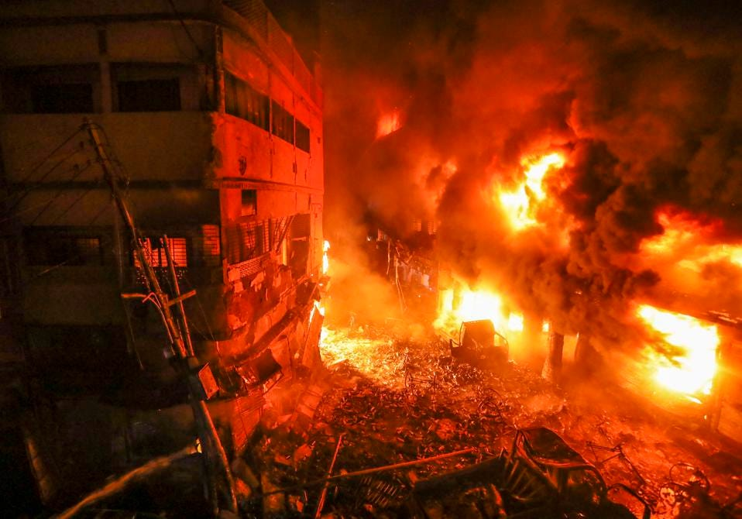
Flames rise from a fire in a densely packed shopping area in Dhaka, Bangladesh, Thursday, Feb. 21,... [+]
ASSOCIATED PRESS
The fire began late Wednesday night. In a small restaurant at the bottom of Wahed Mansion, in the Bangladeshi capital of Dhaka, a young boy was pulling fresh chapati out of the oven as two men stood patiently waiting, watching the boy slap rounds of dough back and forth between his wetted palms. Behind them, cycle rickshaws rattled by on Nanda Kumar Lane. Then something exploded. Fire and dust went everywhere, debris filled the streets and people scrambled to get away as the flames began to spread.
"My son died," said a vendor named Mohammed Alamgir. "He was with me in the store just before the incident. I told him to go home and have his dinner. Ten minutes after he left, I heard some big noise. I came out and saw a large fire."
The blaze ripped through the streets, killing 80 people and leaving whole blocks blackened and gutted. Among the dead were a two-year-old named Tonmoy and a three-month-old named Yasmin. Reports later said a gas canister had exploded in the back of a delivery truck. Or that the truck was part of a wedding procession. Or that a transformer had caught fire. Whatever the cause, the blast took place in the ancient Chawk Bazaar, a bustling labyrinth of winding alleys and tiny shops that offered the fire plenty of fuel — storefronts adorned with colorful plastic garlands, stacks of cardboard boxes, faulty electrical wiring, warehouses full of fabric and illegal stores of chemical barrels used for making cosmetics.
PROMOTED
"Unscrupulous businessmen frequently store and use hazardous chemicals in residential areas, and government agencies have turned a blind eye to this for years," said Muhammad Asif, whose father died in the blaze. "It doesn't matter how many fires and deaths there are, nothing changes."
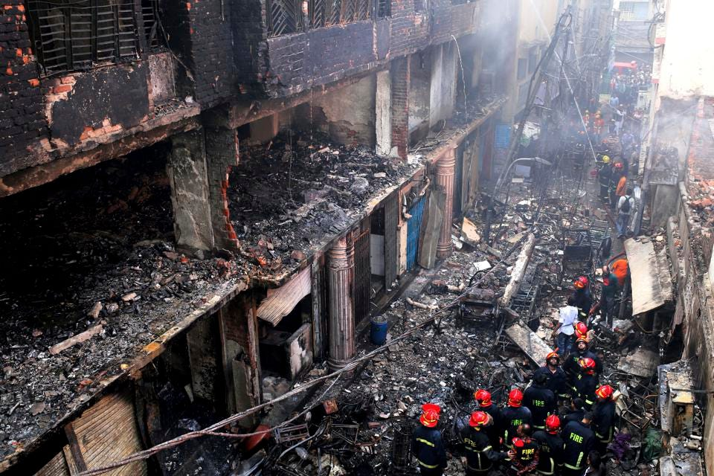
Locals and firefighters gather around buildings that caught fire late Wednesday in Dhaka,... [+]
ASSOCIATED PRESS
Bangladesh is one of the most corrupt countries in the world, and its public sector is no exception. In an interview published today, the architect Mubasshar Hussain said Dhaka is the only capital in the world surrounded by four rivers, yet firefighters struggled to put out last week's fire because Old Dhaka has no water hydrants. Meanwhile, he added, the money spent on building one flyover could be used to supply the entire area with hydrants, yet even though these flyovers reportedly serve only 8% of the city's residents, they continue to be built "because those involved get commission from these projects."
Officials aren't the only ones cashing in at the public's expense. Dhaka is one of the poorest, densest and most populous cities in the world. The country imports 12% of all raw cotton for its textiles industry, which represents over 90% of its exports, making it the second-largest clothing exporter after China. It's a $29 billion industry, but for years, garment workers have only made about $0.35 an hour while multinationals like H&M, Walmart and Aldi take advantage of the country's dismally low minimum wage.
This flood of foreign business has overwhelmed the country, which lacks the infrastructure to meet demand. Working conditions have suffered as a result, and Bangladesh is now one of the worst countries in the world for worker rights. Poor infrastructure, including shoddy electrical work, and stores of fabric and chemical dyes, have also led to disasters such as the 2010 Dhaka fire, which killed 126 people, and the 2012 Dhaka fire, which killed up to 124 people. Then there was the 2013 Rana Plaza collapse, in which workers who evacuated a crumbling building in Dhaka were told to return to work the next day only to have it collapse, taking 1,134 lives. It was the deadliest building collapse in modern history.
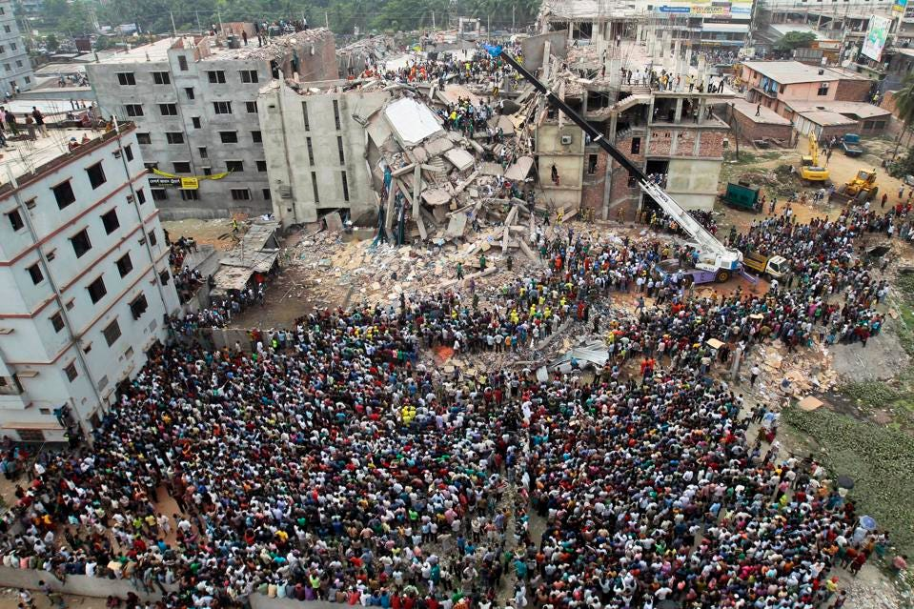
Bangladeshi people gather as rescuers look for survivors and victims at the site of the Rana Plaza... [+]
ASSOCIATED PRESS
Making matters worse, there's little evidence to suggest, as the economist Joan Robinson once said, "The misery of being exploited by capitalists is nothing compared to the misery of not being exploited at all."
In other words, having a sweatshop isn't necessarily better than nothing. A July 2018 study of Ethiopian industrial workers, for example, found that applicants were eager to take fresh new jobs with Chinese, Indian and European factories but few stayed on for long. In a New York Times op-ed summarizing their results, the co-authors concluded:
People who worked in agriculture or market selling earned about as much money as they could have at the factory, often with fewer hours and better conditions...Serious injuries and disabilities were nearly double among those who took the factory jobs, rising to 7 percent from about 4 percent. This risk rose with every month they stayed. The people we interviewed told us about exposure to chemical fumes and repetitive stress injuries."
The idea that people should thank us for the privilege of being exploited is not only contemptible, it doesn't even stand up to scrutiny. The labor historian Erik Loomis has argued that neoliberal globalism and the sweatshops it makes possible have allowed the types of harsh conditions John Updike wrote about in The Jungle to be recreated by U.S. corporations in developing nations. Specifically, he compares the Triangle Shirtwaist Factory fire of 1911, which killed 146 garment workers in New York and became one of the deadliest industrial disasters in U.S. history, to the Rana Plaza collapse. But whereas Triangle, Loomis says, led to a number of important reforms, this isn't happening in Bangladesh.
The difference is that most of us can't even find Bangladesh on a map, not to mention know enough about it to express the type of outrage our ancestors did after Triangle. This separation of production from consumption is an intentional move by corporations precisely to avoid being held responsible by consumers for their actions. And it is very effective."
This feels especially unjust given the generosity of its people. Having just won their independence from Pakistan in 1971, theirs is a young nation, and one of the poorest on earth, yet they give more to charity than much wealthier nations such as Japan, Russia or China, and they shelter more refugees than anywhere else — Kutupalong, the world's largest refugee camp, contains over 1 million Rohingya.
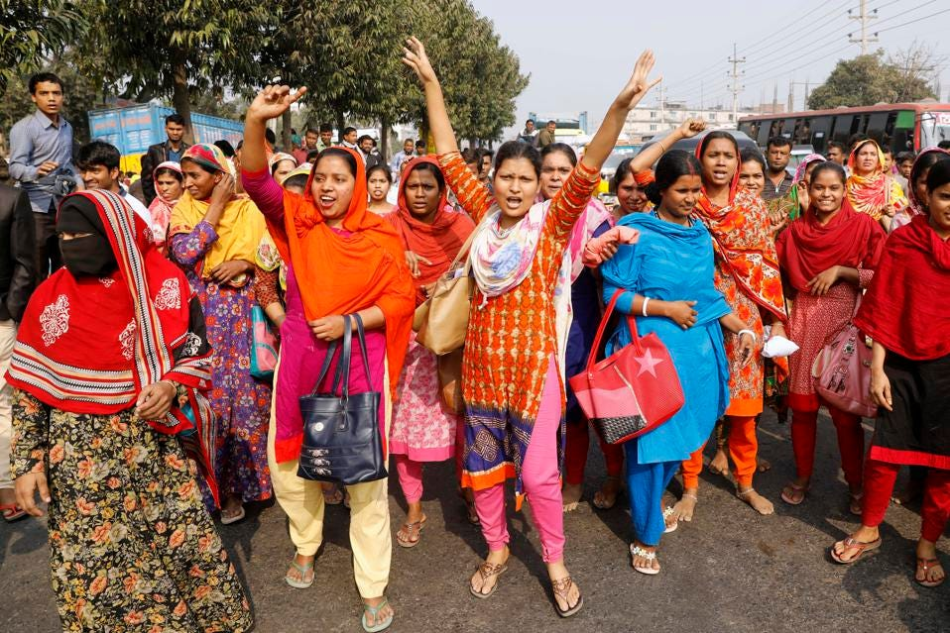
Bangladeshi garment workers shout slogans during a protest in Savar, on the outskirts of Dhaka,... [+]
ASSOCIATED PRESS
But progress has been made, though there's still much left to be done. The 2012 Dhaka fire led safety groups to agree on new fire safety standards, and weeks after the Rana Plaza collapse, companies and trade unions formed the Accord on Fire and Building Safety in Bangladesh — including H&M, Zara, American Eagle Outfitters and Uniqlo. North American companies followed suit with the now-defunct Alliance for Bangladesh Worker Safety. But as of 2017, 95% of buildings in Dhaka still do not have a fire exit, yet much needed support for the Accord is slipping.
"Despite the fact that the Accord has reached a 89% remediation rate for the around 1,600 factories that it covers, it is now at risk of being curtailed or expelled from Bangladesh," Christie Miedema, campaign coordinator for the Clean Clothes Campaign, told Forbes, "The government of Bangladesh has repeatedly stressed that it is high time that national inspection agencies take over the Accord's monitoring work, but recent fires have once more shown that those agencies are not yet up to that task."
Also, last December, garments workers finally negotiated a raise to the minimum wage, but the new minimum wage is just $0.42 an hour, and it only applies to the lowest earners, leaving middle-income wages no better. This touched off protests in January, and one man died in the clash.
Since last week's fire, the government has also formed a task force to locate illegal chemical storehouses, finally addressing an old source of outrage. As one reader commented in the wake of the blaze, "How many bodies will burn before the authorities remove the chemical warehouses from old Dhaka?"
This cuts to the heart of the matter. Bangladesh isn't in trouble because it's poor. It's in trouble because people are wealthy enough to take advantage of that poverty, whether multinationals, government officials or merchants illegally storing supplies to meet corporate demand. “This isn’t about poverty, it’s about greed,” said Nizamuddin Ahmed, an architect in Dhaka. “The people storing these chemicals in residential buildings are rich — they have cars, nice homes, children studying abroad.”
But even this is meager progress compared to what's left ahead. No permission to store chemicals in the area has been given for the last seven to eight years, said Shamsul Alam, chief inspector of the Department of Explosives. But in the basement of one of the burned buildings, officials found hundreds of chemical drums, luckily untouched by the fire.
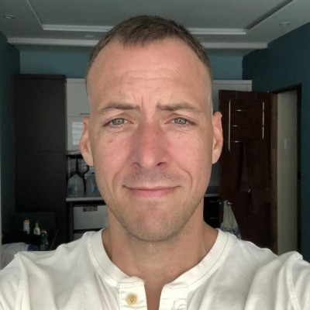
David Volodzko
I am an editor at the technology and information company Brightwire, where I handle issues related to trade, energy and technology. My writing has appeared in The Wall Street Journal, Bloomberg, CNN, The New Republic, Slate and Vice. I am also the former national editor of The New York Times sister paper in South Korea, the Korea JoongAng Daily, a former Korea correspondent for South China Morning Post and a former contributor on Chinese affairs for The Diplomat. Before that, I worked as a university lecturer. After over 15 years in Asia, I now live in the United States. Read Less

