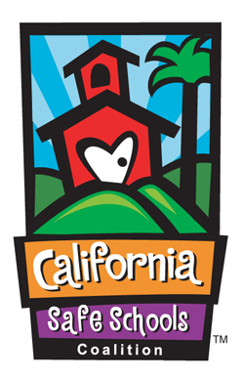
Robina Suwol & California Safe Schools

Founded by Robina Suwol in 1998, California Safe Schools (CSS) is children’s environmental health and environmental justice coalition. CSS achieved national prominence by spearheading the Los Angeles Unified Integrated Pest Management (IPM) Policy, the most stringent pesticide policy in the nation for K-12 public schools and the first to embrace the “Precautionary Principle” and “Right to Know”. The success of the policy led to California’s Healthy Schools Act. Today the LA Unified IPM policy serves as an international model for school districts and communities.
On October 6, 2005, Governor Schwarzenegger signed AB 405 (Montanez) sponsored by California Safe Schools. The bill bans experimental pesticides, whose health effects are unknown, from California k-12 public schools. As a result, more than 6 million California children and hundreds of thousands of school children are protected from experimental chemicals, whose health effects are unknown.
CSS continues to be a leader on children’s environmental health, with an emphasis on schools and environmental justice communities. Under Robina’s leadership, CSS has facilitated changes at the policy level as well as at the grassroots, which creates a lasting institutional protection. Website: www.calisafe.org
Los Angeles Unified School District
Integrated Pest Management Policy
http://www.calisafe.org/policy.html

California Healthy Schools Act
https://www.cdpr.ca.gov/docs/pestmgt/pubs/hsa_factsheet.pdf

AB405 (MONTANEZ)
http://www.calisafe.org/ab405.html

https://www.cdpr.ca.gov/docs/schoolipm/school_ipm_law/prohibited_prods.pdf
Guardian article on LA lead in school:
https://www.theguardian.com/us-news/2022/apr/25/california-high-school-watts-pollution

For further information:
Robina Suwol
Executive Director
California Safe Schools
818.785.5515 office
Email: calisafe@earthlink.net

Warm Regards,
Robina

