Los Angeles confronts its shady divide

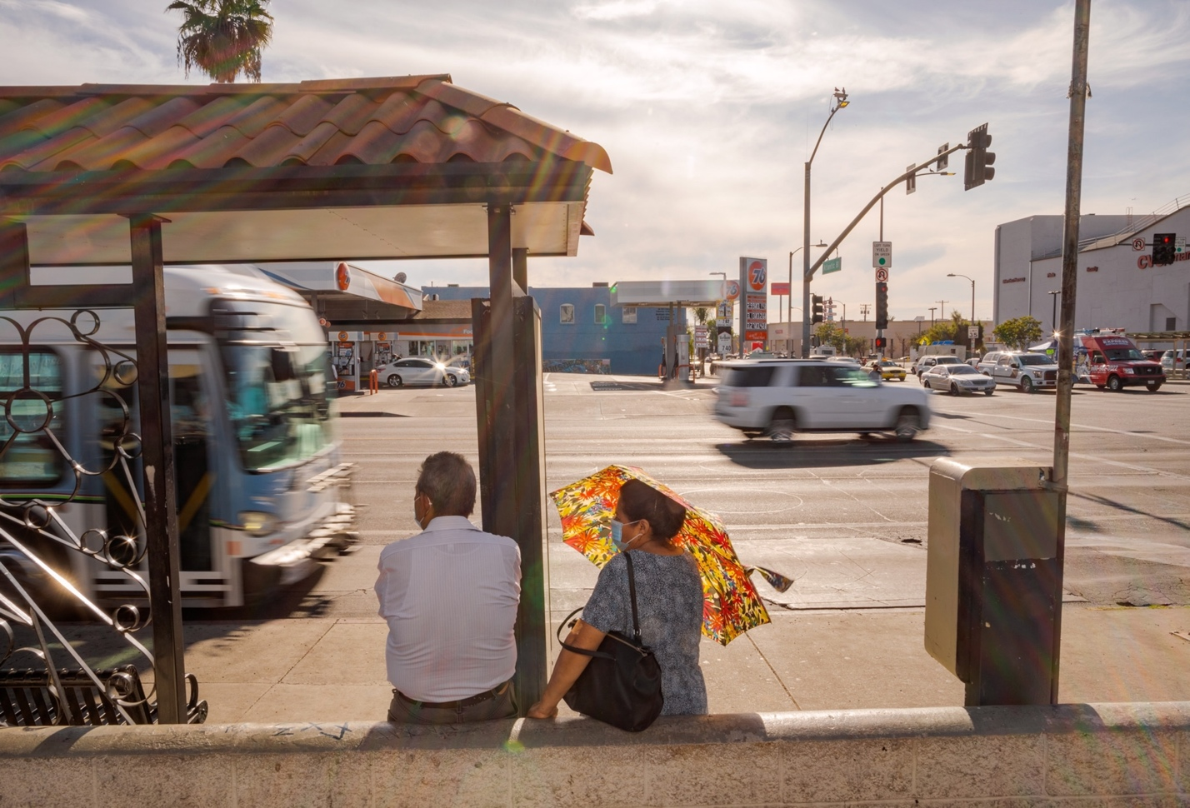
A lack of tree cover in low-income areas has left many residents especially vulnerable to rising heat. It’s a legacy of the city’s design—and its history of racist policies.
L.A.’s year-round sunshine has generally been considered a blessing. But it can make a long wait for a bus uncomfortable.
ByAlejandra Borunda
Photographs ByElliot Ross
Published June 17, 2021
• 20 min read
Hear more about cooling cities by throwing shade in our podcast, Overheard at National Geographic.
Miguel Vargas vividly remembers when he first understood the power of shade. He was in middle school, sprinting up and down a scrubby soccer field in Huntington Park, a small city laced with train tracks and high-voltage transmission lines just south of the Los Angeles skyline. He ran so hard in the battering sun that he overheated.
His vision went fuzzy. His heart pounded. In a daze he stumbled toward a towering red pine near the southwest corner of the field—the biggest and almost the only tree in sight.
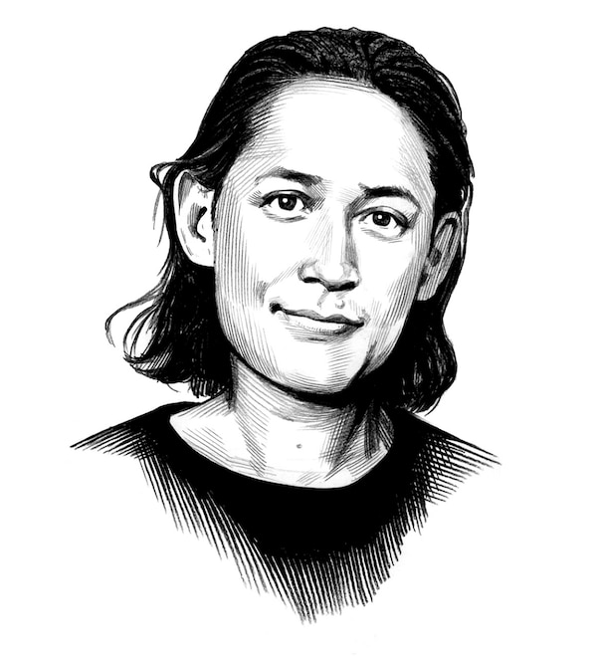
The National Geographic Society, committed to illuminating and protecting the wonder of our world, has funded Explorer...
ILLUSTRATION BY JOE MCKENDRY
In that shelter, Vargas’s dizziness receded. His heart rate mellowed. He returned to himself, revived by the deep, cool shadow.
That simple blessing, he learned later when he took a job planting trees, is abundant elsewhere in L.A., primarily in rich, mostly white neighborhoods. But in predominantly Black and brown neighborhoods such as Huntington Park, which is 97 percent Hispanic, shade is vanishingly rare. (Oregon once legally banned Black people. Has the state reconciled its racist past?)
Los Angeles isn’t Phoenix or Dallas. It has a moderate climate. But it too experiences deadly heat—and here, unlike almost any other U.S. city, it can strike year-round. Climate change is worsening the problem. It’s already time to “turn off the sunshine,” says L.A.’s chief design officer, Christopher Hawthorne. The city, he says, needs to find ways to build cooling, potentially lifesaving shade into its fabric.
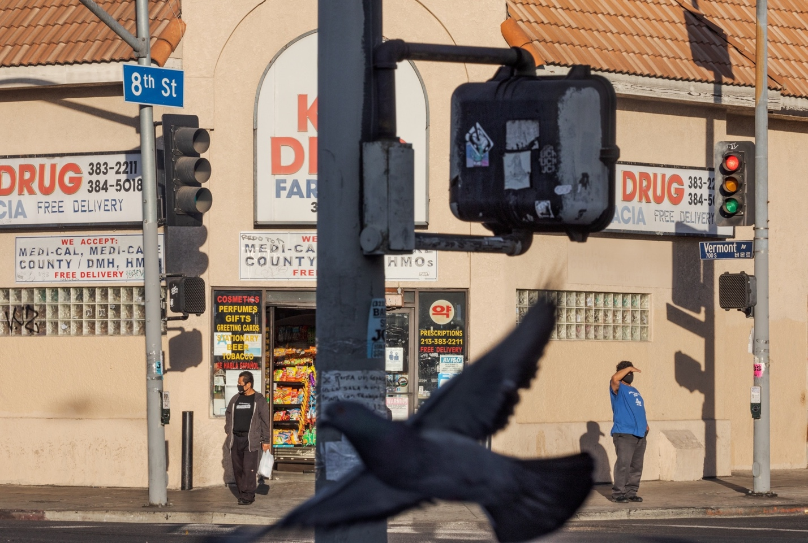
Los Angeles’s car-centric design makes it seem as if the city is meant to be seen from an air- conditioned vehicle. Without much shade, pedestrians such as these at Vermont Avenue and Eighth Street, just west of downtown, often bake in the sun.
Modern Los Angeles is a city built on sunshine, not shadow. In the late 1800s and early 1900s, Southern California boosters enticed migrants from the East with visions of “almost everlasting sunlight.” The allure of L.A.’s exceptional light has persisted, featured by Hollywood, celebrated by homegrown artists such as Robert Irwin. “On many days the world almost has no shadows,” Irwin told the New Yorker in 1998. “Broad daylight—and in fact, lots and lots of light—and no shadows.”
“Sunshine,” says Hawthorne, “had become one of our central commodities.”
Urban design in Los Angeles prioritizes access to the sun. The city code often defines where or for how much of the day a building can cast a shadow, lest it overly shade courtyards, parks, or patios. Architects have designed buildings to be transparent to sunlight and entire complexes to let it enter each corner. After the 1970s’ energy crisis, the city had a new reason to ensure sun access everywhere; today, L.A. has more solar power capacity than any other American city.
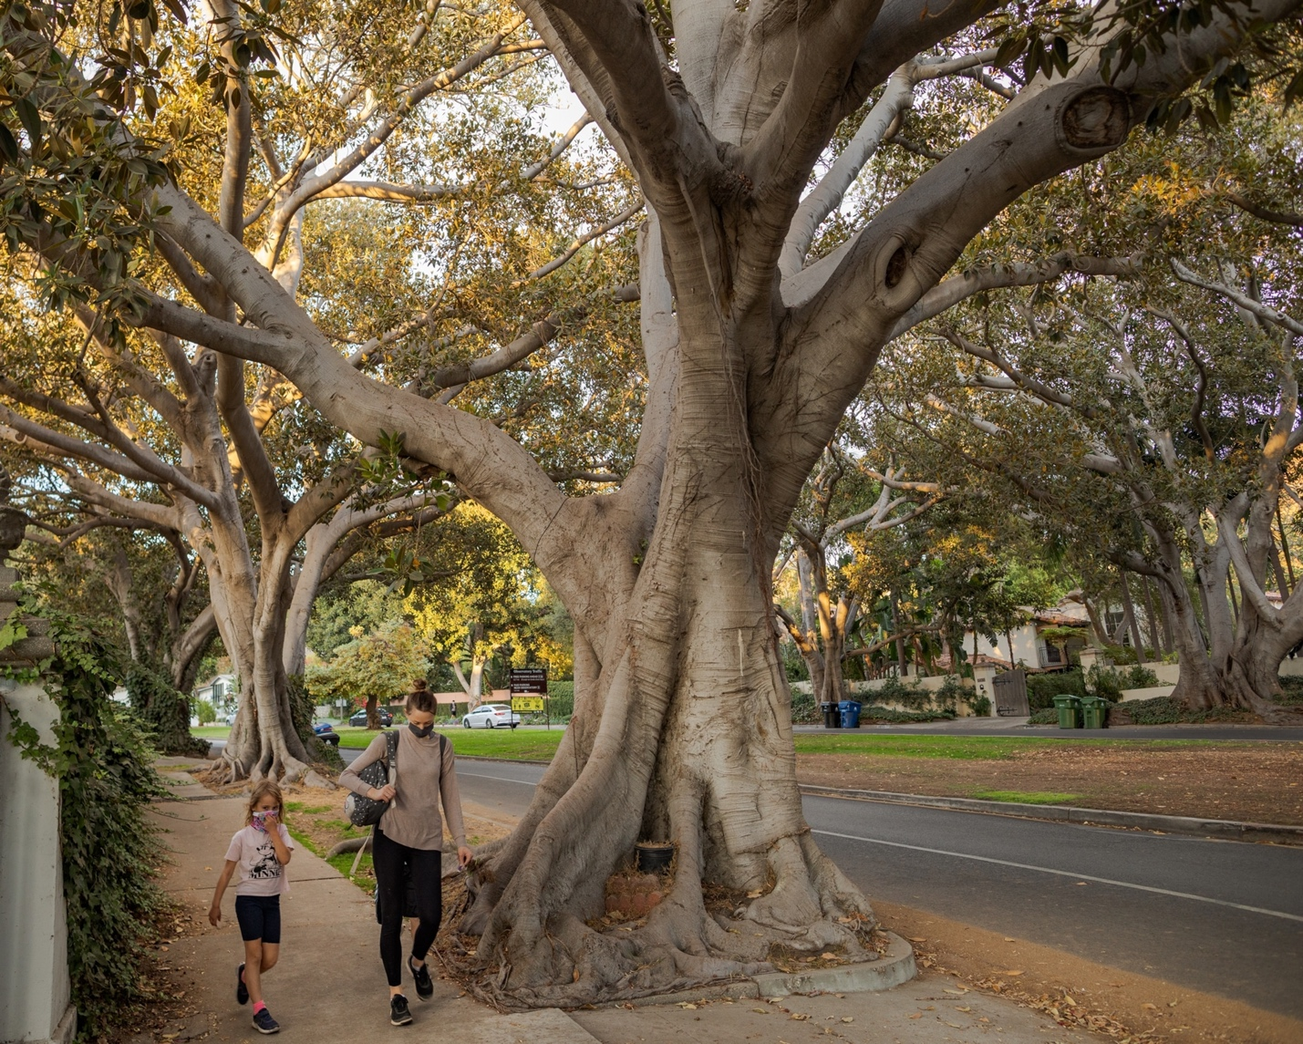
At the northern end of Vermont Avenue in Los Feliz, Moreton Bay fig trees arch over a grassy median where people lounge on hot days. The trees, planted around 1913 and carefully tended since, are on the Los Angeles list of historic monuments.
But in the age of climate change, L.A.’s sunshine is no longer an unqualified boon. By mid-century, absent major international efforts to rein in carbon emissions, L.A. is expected to experience 22 days a year above 95 degrees Fahrenheit, more than triple the current number. The suburbs in the San Fernando Valley may see more than 90 days—a full quarter of the year. Heat already increases the risk of death in Los Angeles, even when it isn’t the proximate cause. During a short heat wave, the death rate from all causes rises by 8 percent above normal. After four or five days, that number swells to 25 percent—and up to 48 percent among older Black and Latino residents. (Too hot to live: Millions worldwide will face unbearable temperatures.)
“The really simple thing, if you care about making people more comfortable, is just to offer more opportunities for shade,” says V. Kelly Turner, an urban planner at UCLA.
On a hot day you feel much hotter in the direct sun than in the shade, even if the air temperature is the same. That temperature is a measure of how fast air molecules are moving and are heating you as they bump into you—but solar radiation heats your body too. In direct sunlight you might feel as much as 20 degrees warmer than in nearby shade.
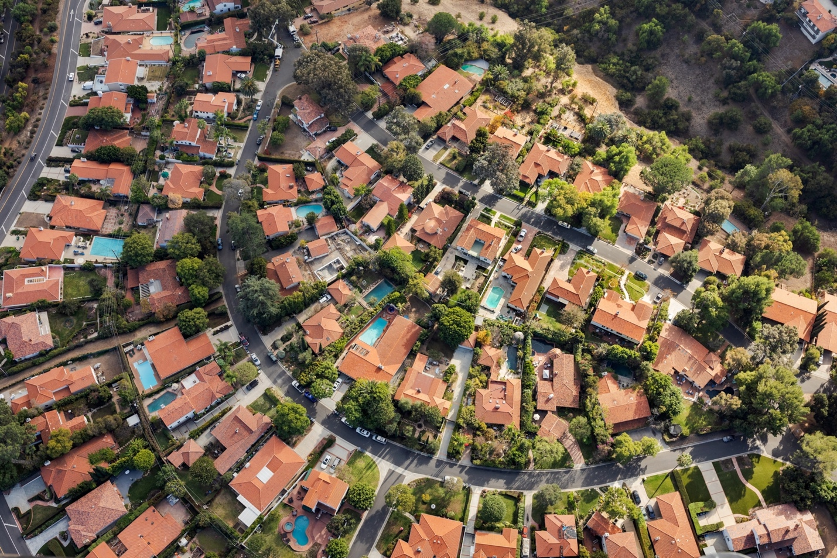
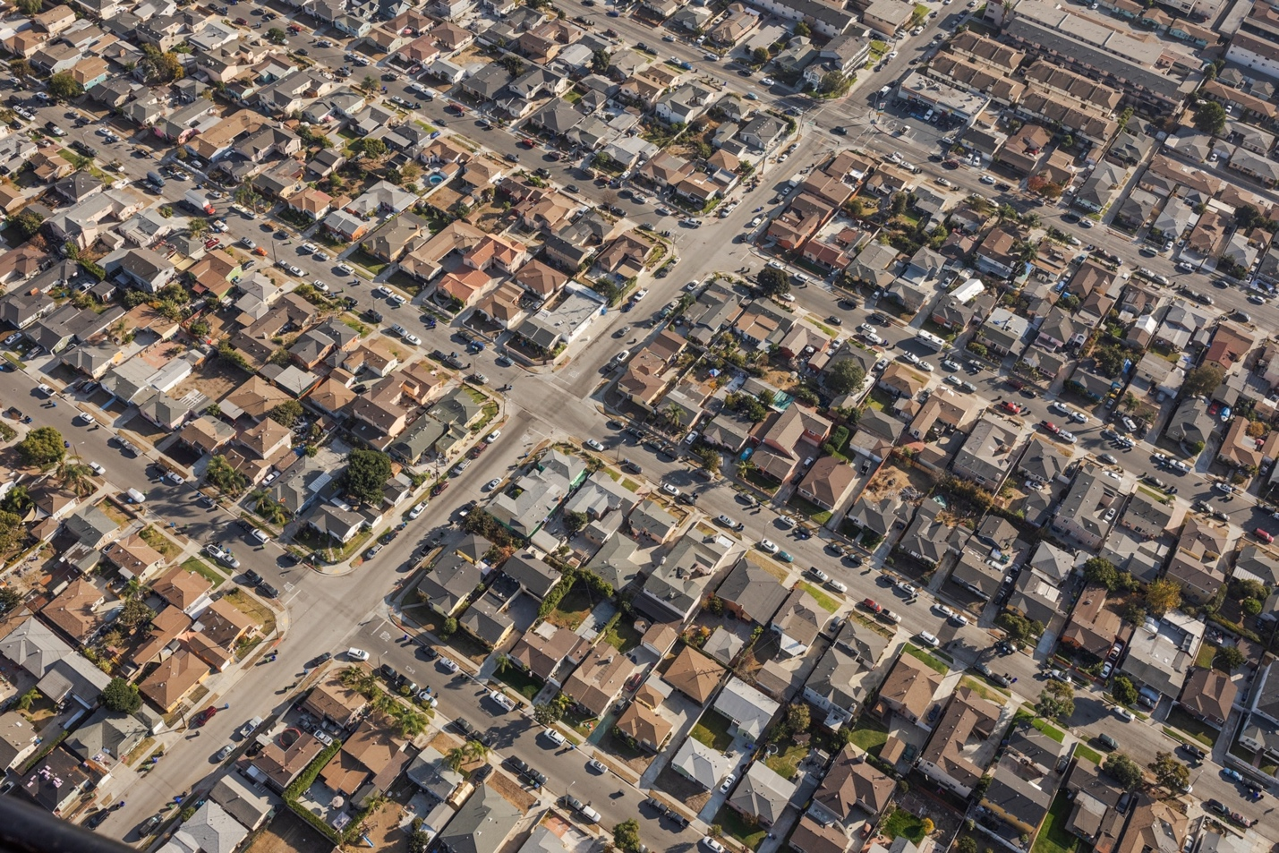
Left: Most shade in L.A. is in communities such as Rolling Hills, where people can afford to care for the trees.
Right: In low-income, largely minority areas such as Hawthorne, lack of public investment means fewer trees.
The same is true for buildings, sidewalks, and other massive objects: Direct solar radiation imparts more energy and therefore heat. Asphalt is a particularly good absorber, and along with concrete it releases that captured heat into the air for hours, even after the sun disappears, contributing to the urban heat island effect. A well-placed tree, on the other hand, can keep a building 18 degrees cooler than if it were fully exposed to the sun. Shade keeps everything cooler—and the overheating city is taking note.
When Spanish colonizers arrived in the Los Angeles Basin, they found a landscape carefully managed by the Tongva and other Native inhabitants, a rich ecological patchwork with profuse pockets of shade. Forests of oaks and other trees meandered along the rivers and in the highlands that now make up East Los Angeles, providing shade and showers of nutritious acorns. A village called Yaangna, near today’s downtown L.A., was “a very lush pleasing spot in every respect,” wrote Father Juan Crespí, an early missionary who visited in 1679.
The Spanish felled many of the oaks for lumber and cleared other tree-dotted land for cattle. They created shade with buildings rather than trees: Streets were laid out roughly 45 degrees off of north-south, to maximize sun and shade exposure year-round, and long, arched loggias lined the external walls of missions and residences.
A street-level view of L.A.’s urban inequity
Trees become sparser and neighborhoods hotter as you drive from north to south along Vermont Avenue. Over about six miles, the road passes through areas that show the enduring effects of housing discrimination through redlining, which ranked areas from A (“green,” or most suitable for investment) to D (“red,” or least suitable).

Grade A — Los Feliz
At the north end of Vermont Avenue in Los Feliz, spreading fig trees line the avenue. In this and other affluent grade A areas, a 1939 map notes, deed restrictions left ownership of some houses “limited in perpetuity to Caucasian” buyers.

Grade B — Los Feliz
Downhill and half a mile south, small apartment buildings line the street, but there’s still room for plenty of trees. Areas that were considered “reasonably homogenous” were given a B grade.

Grade C — East Hollywood
This part of Vermont Avenue has larger commercial buildings and more parking lots, leaving space on the streets for only a few trees. Neighborhoods that had proximity to non-white communities were given a C grade due to a perceived risk of "infiltration" from other groups.

Grade D — Pico-Union
Trees are all but absent here, where Vermont Avenue streetscape is dominated by pavement. Bureuacrates gave a D grade to areas for having so-called “subversive racial elements," which included African Americans, Jews, and people of Mexican and Japanese descent.
Streetscape photographs by Elliot Ross
Settlers from the eastern U.S. reshuffled the shade landscape once again in the 19th century, planting new crops and citrus orchards. In the 20th century, using water siphoned from outside the Los Angeles Basin, they eventually created an “urban woodland,” says Travis Longcore, an environmental scientist at UCLA. Especially after World War II, a neat single-family home with a car in the driveway and a pretty tree on the front lawn became the embodiment of the American Dream—and the booming L.A. population embraced it. Tree density grew by 150 percent from the 1920s to the early 2000s, when well over 10 million trees dotted the city.
(See how L.A.’s patterns of trees and heat can be traced back to racist maps drawn in 1939.)

How L.A.'s urban tree canopy reveals hidden inequities
See how the city’s patterns of trees and heat can be traced back to racist maps
drawn in 1939.

But urban forests grow on money, which is not distributed equally. Most shade in Los Angeles fell on privately owned land, in places such as Los Feliz, Hollywood, or Brentwood, where people could afford trees and their often expensive care. Today, nearly 20 percent of the city’s trees can be found in just five census blocks, home to just one percent of the population. (How these 1930s maps left some neighborhoods with fewer trees.)
In contrast, trees did not sprout as readily in the poorer, Blacker, and browner parts of the city. Redlining in the first half of the 20th century had denied many people of color mortgage financing for the American Dream and had led to massive disinvestment in public goods, including trees. Public trees planted in such neighborhoods often were neglected by the underfunded forestry department, leaving residents to deal with broken branches, buckled sidewalks, and wilting greenery. Furthermore, to make way for cars, the city removed trees along streets and narrowed sidewalks. Trees were also felled or trimmed to allow street surveillance by L.A. police helicopters. (Racist housing policies have created some oppressively hot neighborhoods in Minneapolis.)
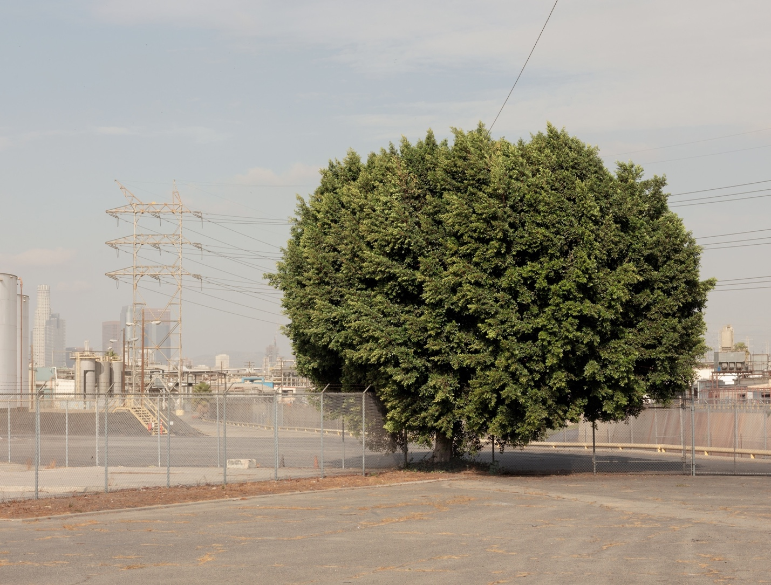
A lone tree grows on a lot in Vernon, an industrial area near downtown L.A. where surfaces can be more than 15 degrees Fahrenheit hotter than in leafy neighborhoods. Only a hundred or so people live in this sun-blasted place, but some 50,000 come here to work.
The disparity is stark: In some of the city’s poorest neighborhoods, such as Huntington Park, trees shade well under 10 percent of the area, while in better-off places, such as Los Feliz, the canopy coverage can hit nearly 40 percent. That has a direct impact on public health. Formerly redlined neighborhoods are on average 7.6 degrees hotter than the richest ones. (How ‘nature deprived’ neighborhoods impact the health of people of color.)
“You just don’t see green in the areas that were redlined,” says Vivek Shandas, an urban ecologist at Portland State University who is advising L.A. on equitable tree planting.
On a few stretches of Vermont Avenue in Los Feliz, the roots of decades-old Moreton Bay figs fill eight-foot-wide tree wells on both sides of the quiet, divided roadway. Luxuriant branches meet over the 40-foot-wide median. Murky, cool light flickers to the grass below. But seven miles south on the same street, in South Central Los Angeles, the sun beats down unimpeded.
One day last winter, it shone on Rachel O’Leary and Cindy Chen, of a nonprofit called City Plants, who were looking for places to plant trees in South Central. On one long block with 33 residential lots, they found just nine street trees. Six were so immature, they cast only a dollop of shade. A white mutt soaked in the cool under an overtrimmed jacaranda; construction workers rested under two fat-trunked figs. The rest of the block was open to the sun.
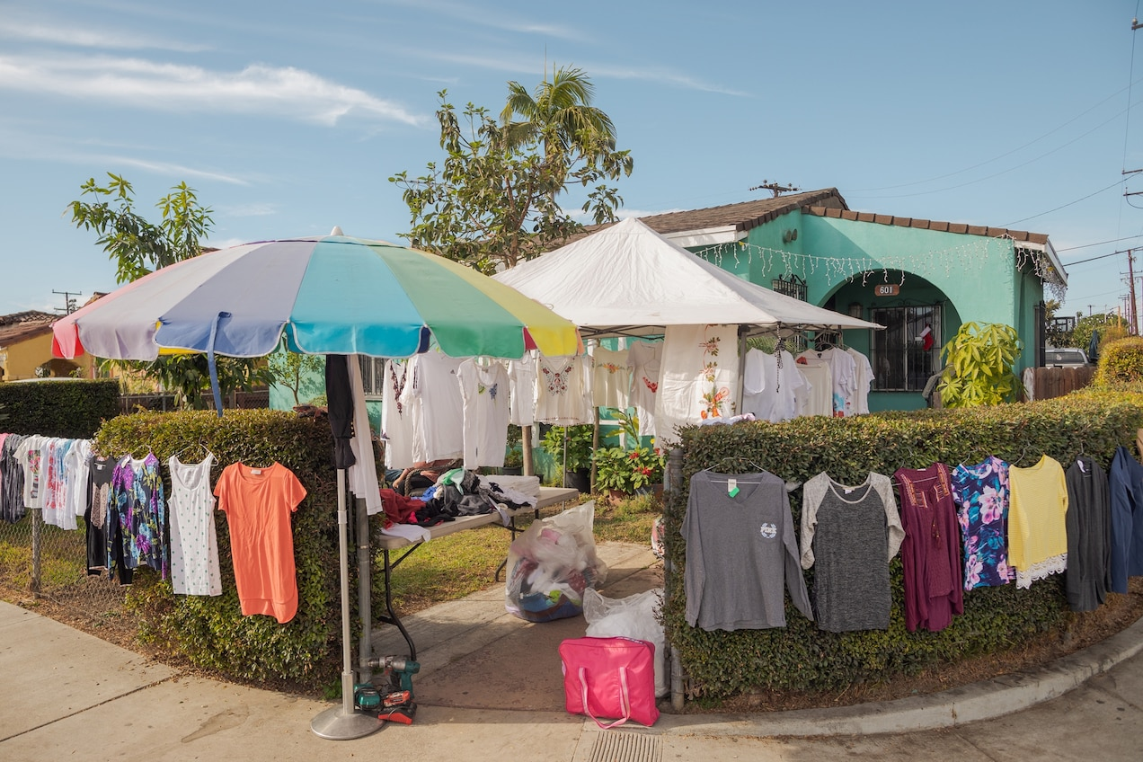
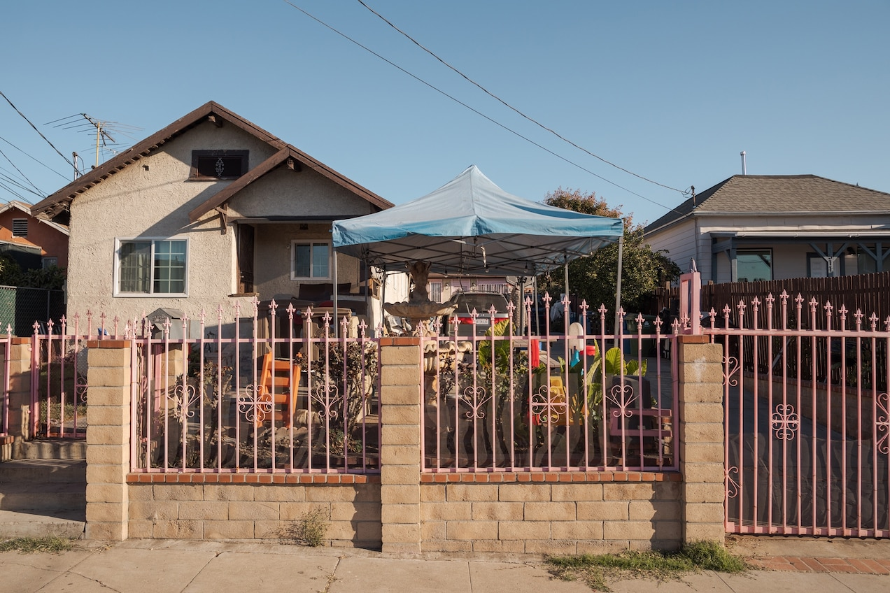
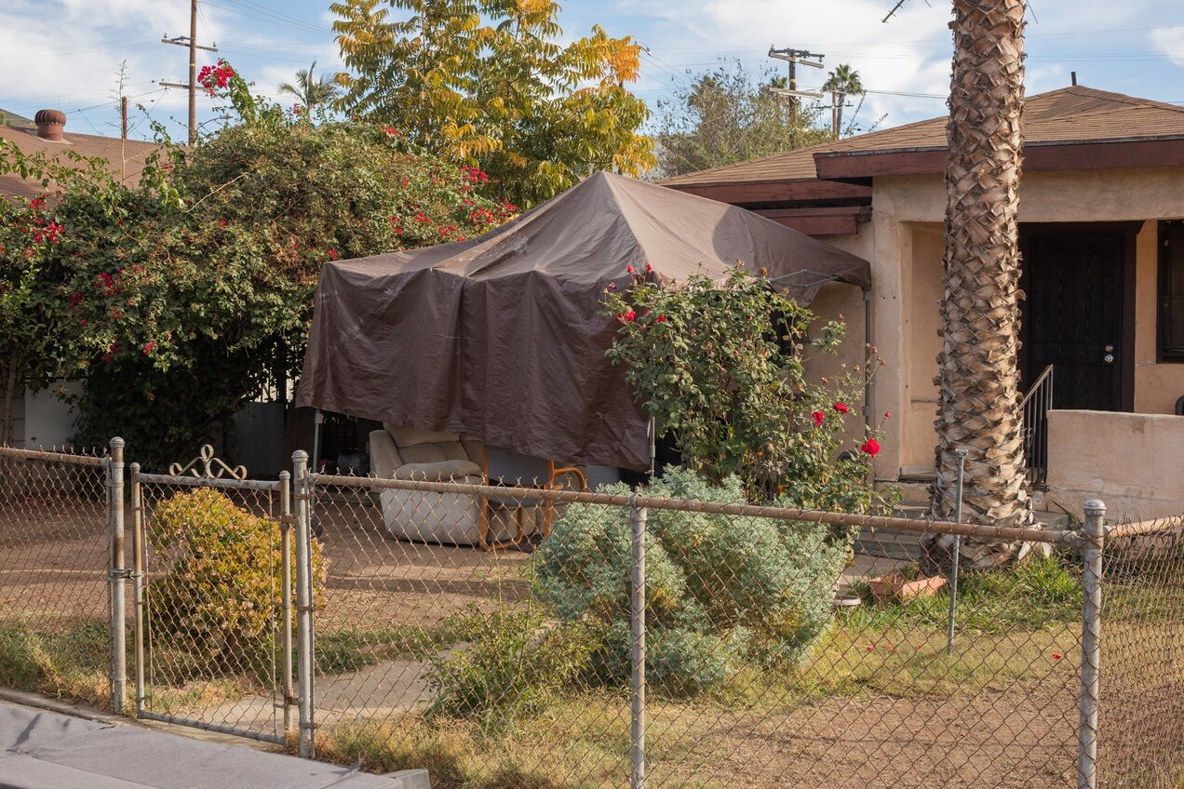
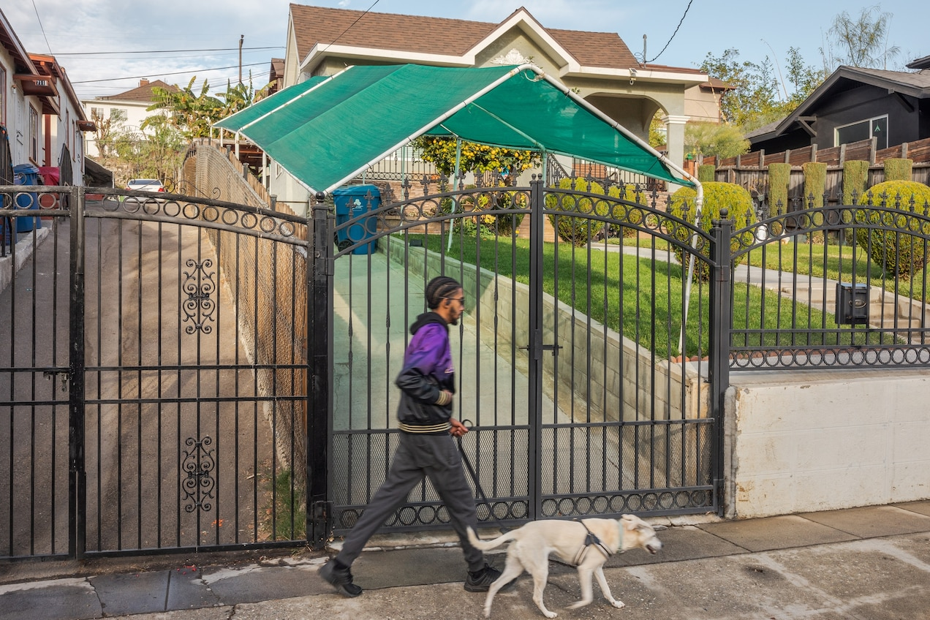
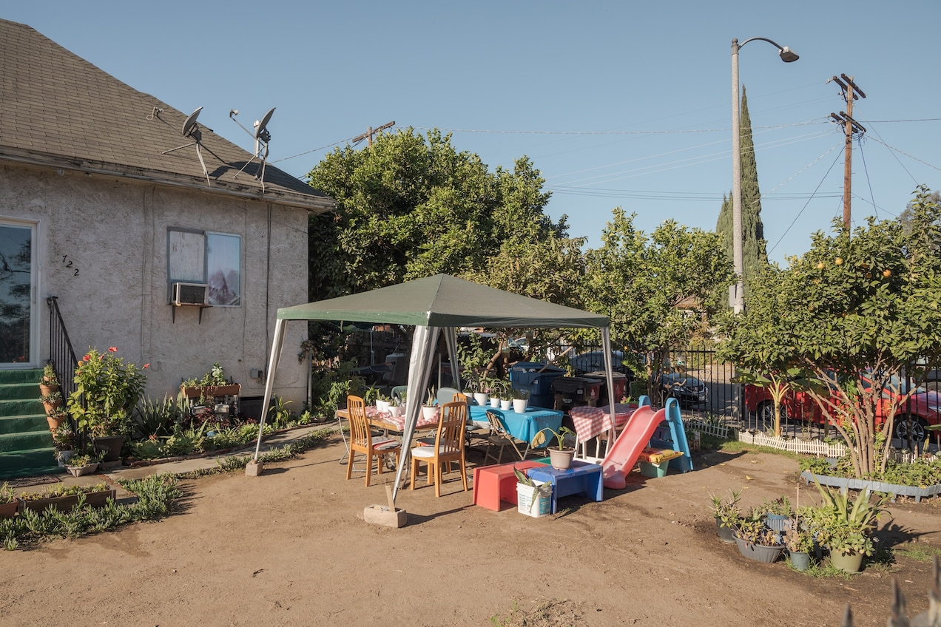
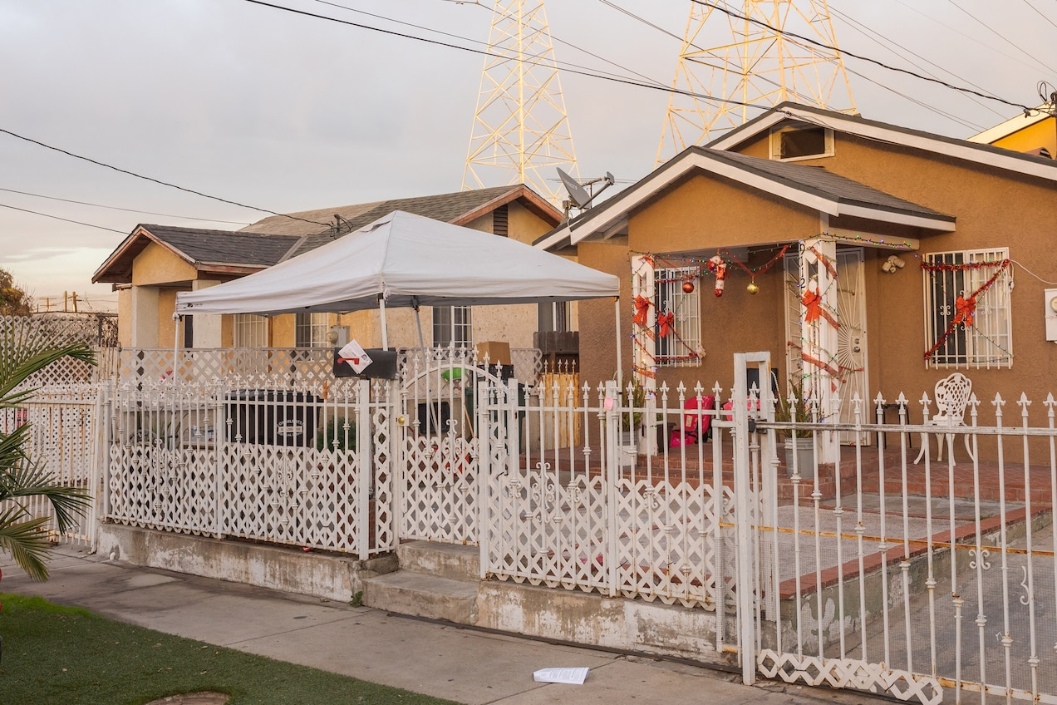
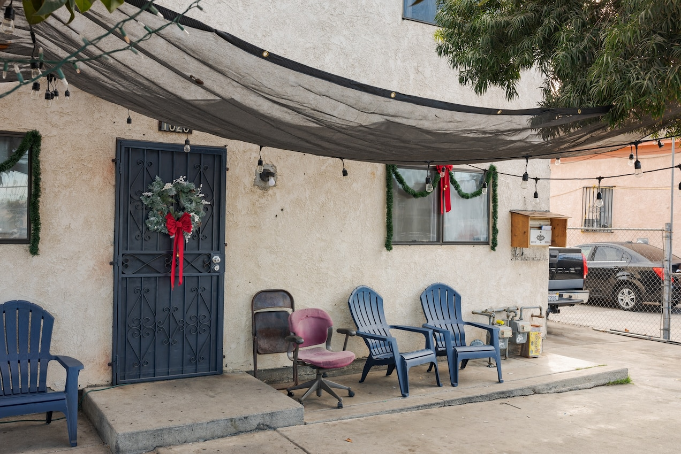
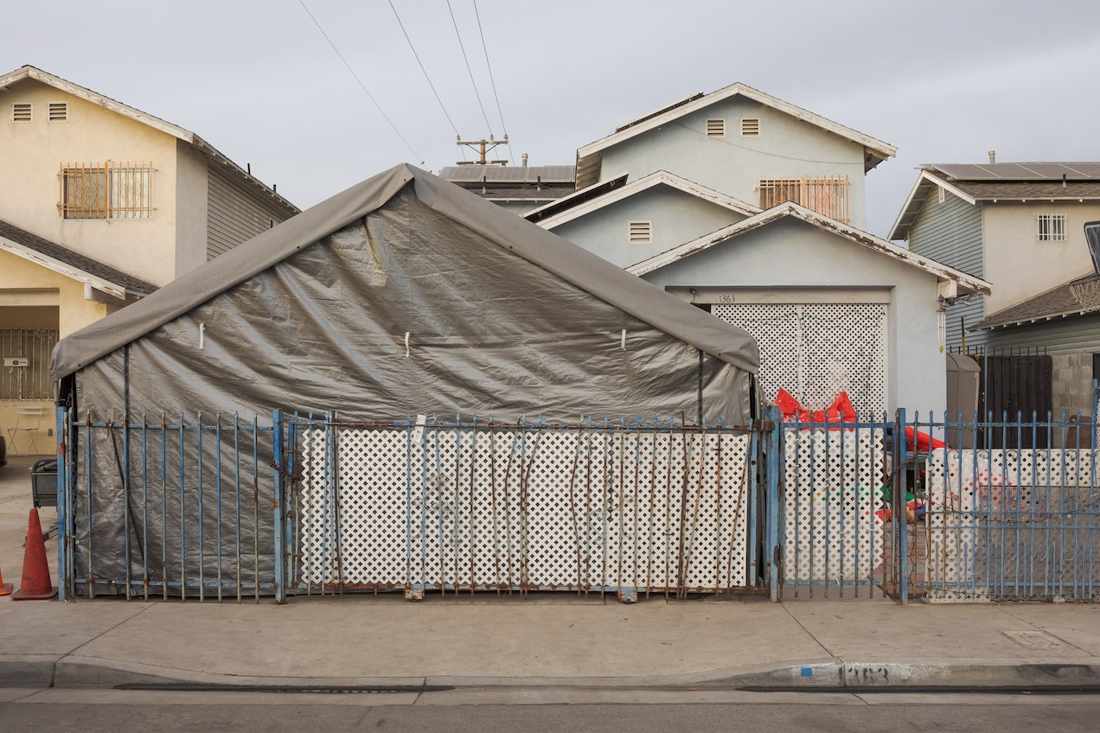
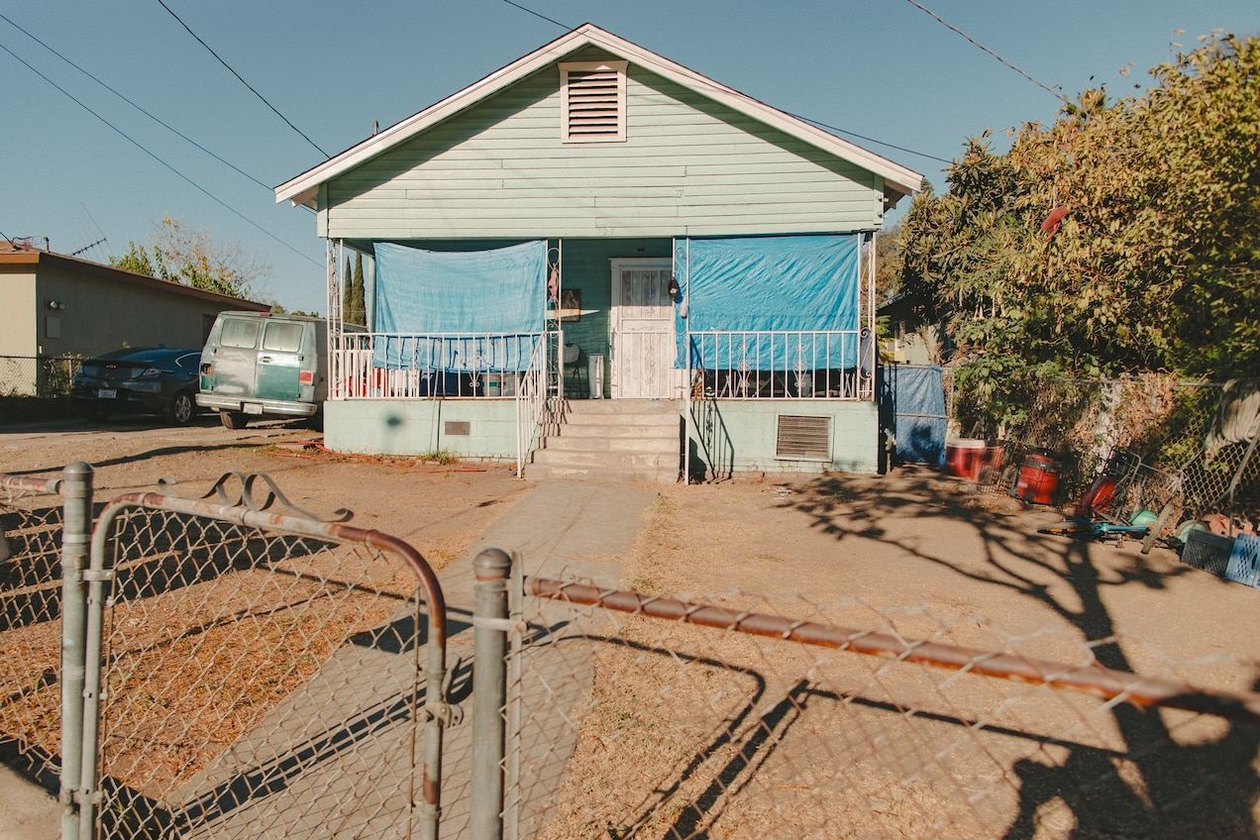
1 / 9
Many L.A. residents, particularly in Latino neighborhoods, have mastered the art of homemade shade solutions, says urban planner James Rojas. The defining aesthetic is rasquachismo, a Chicano term for resourceful, cheerful cobbling together of whatever is around to create something vibrant and functional. Houses in the region often lack central air-conditioning or good ventilation, so access to comfortable outdoor spaces is essential.
Many L.A. residents, particularly in Latino neighborhoods, have mastered the art of homemade shade solutions, says urban planner James Rojas. The defining aesthetic is rasquachismo, a Chicano term for resourceful, cheerful cobbling together of whatever is around to c...
Chen has built a computer model that finds the little wedges of land where the city could add trees, a trickier proposition than it sounds. Of the 88,500 square feet of publicly managed land on this block (including the street), only about 10,800 square feet are even potentially plantable. Chen’s model picked out places that couldn’t fit trees because of driveways, fire hydrants, alleys, and other obstacles such as water and gas meters or power poles. What was left was enough space, in three-foot-wide strips along the narrow sidewalks, for 16 more street trees.
That’s not a lot, O’Leary admits. But this area currently has less than 3 percent canopy cover. “Some trees are better than no trees,” she says.
Los Angeles aims to plant 90,000 more trees by the end of 2021, with the goal of increasing canopy cover by 50 percent by 2028 in neglected neighborhoods like South Central. The campaign is far from a panacea, the city’s forest officer, Rachel Malarich, says bluntly. Trees take years if not decades to mature and require significant watering. But their benefits, she says, far outweigh the costs.
Christopher Hawthorne is advocating a holistic approach that integrates shade considerations into all public urban design decisions in L.A. “Rather than embracing sun and sunshine,” he says, “we need to start thinking about designs that could protect us from sun and heat.”
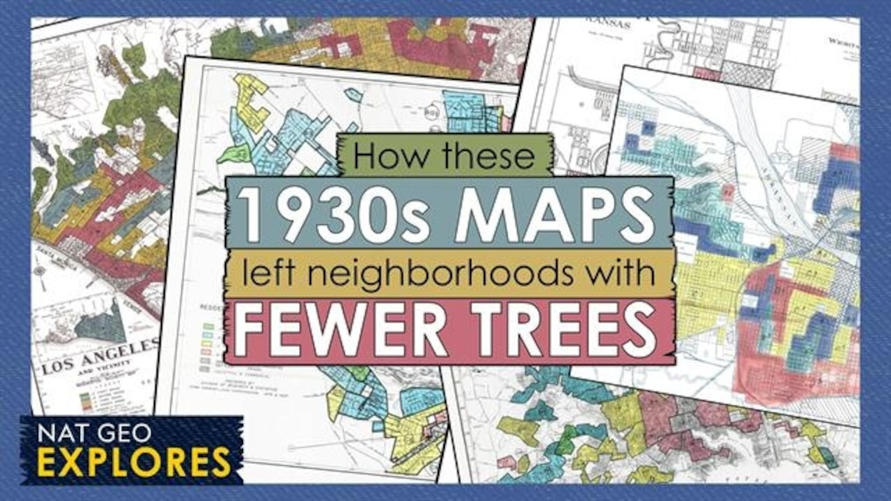
6:35
How these 1930s maps left some neighborhoods with fewer trees
More than 50 years after redlining was banned by the Fair Housing Act of 1968, its lingering effects leave many low-income and often communities of color with fewer trees to keep their neighborhoods cool.
At the broadest scale, that would entail reorienting the city itself away from cars, returning space to pedestrians—and trees. It might mean narrowing streets and allowing them to be shaded by taller buildings than current codes permit. There are laws governing the right to heat in buildings, and in Europe even to sunlight; maybe it’s time to assert a right to shade and cool, Hawthorne says.
For now, the city is starting small. In a design competition to reimagine streetlights, contestants had to make them do double or triple duty—provide light, add shade if they could, and perhaps host art. Bus shelters are next up for a redesign, and even before then the city is working on adding 750 shelters at heavily used stops on the hottest streets. At UCLA, engineer Aaswath Raman is developing optical materials that shoot the sun’s incoming energy back out to space; a shelter made of such material would not only block the sun, it would cool the air beneath it.
Any shade from any source would be more than welcome, Esmerita Gómez says as she waits for a bus at the corner of Vermont Avenue and Venice Boulevard near downtown L.A. “There were three trees here once. But they cut it down.” She stands carefully in the narrow shadow of a telephone pole until the bus groans to a stop in front of her.
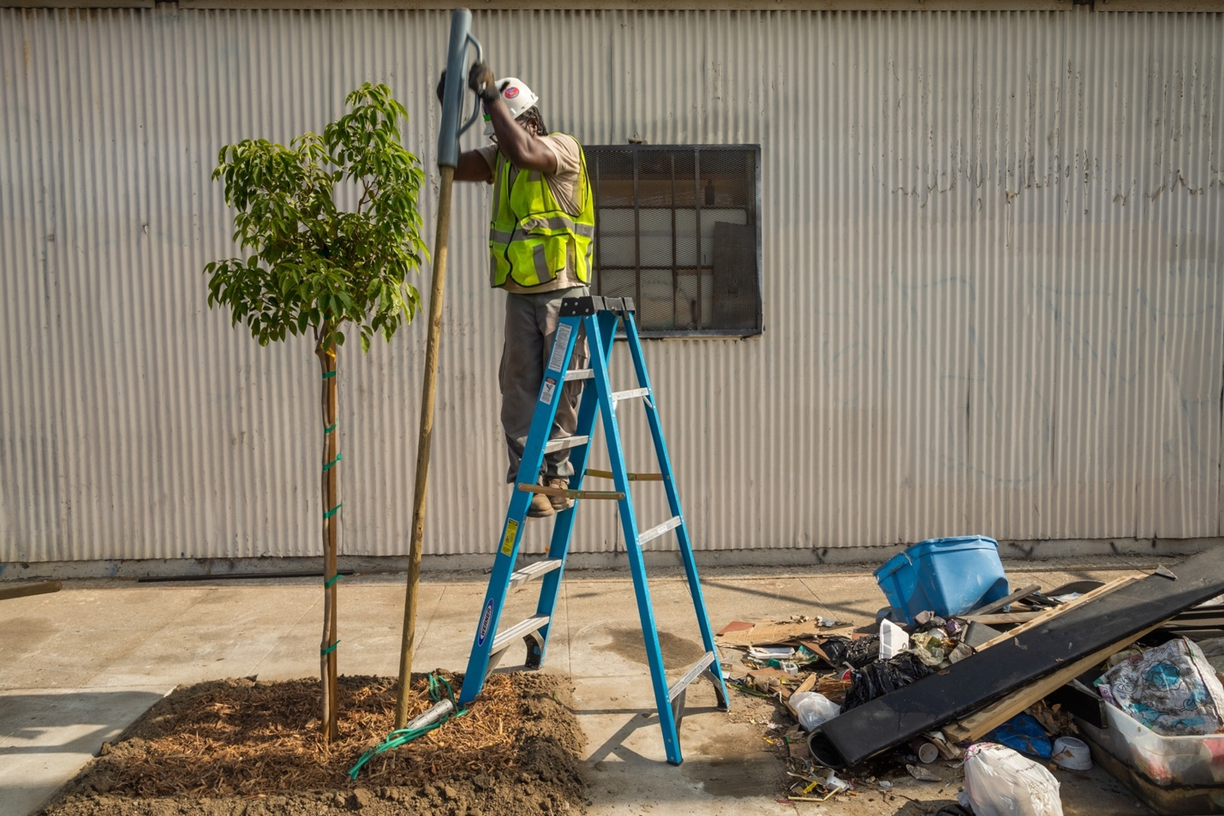
Ladale Hayes plants a pink trumpet tree in Watts, part of an L.A. campaign to plant 90,000 trees by the end of 2021—and many more after that. Working for North East Trees, a nonprofit, Hayes leads a team of young adults, most of whom are planting in the neighborhoods wh...
Finding or making shade is a well-honed skill for Latino residents of the city, says James Rojas, a city planner who grew up in East L.A. Take the patios, porches, and yards of Boyle Heights: They’re a rasquache pastiche of creative shade solutions. Bamboo mats tied to wrought-iron fences. Faded umbrellas lashed into place and colliding with bougainvillea-laced trellises. Tarps strung in elegant, overlapping swoops—“to protect mi padre y la Virgen de Guadalupe,” says Gubernal Velasquez, gesturing from under a neat white awning toward his aging father and a nearly life-size religious icon, both in deep shade. These are design solutions born out of necessity, Rojas says, that the city can learn from and encourage while waiting for the tree canopy to grow in or the city itself to be reshaped.

L.A. is not alone
Baltimore, Maryland, is also hiring residents to plant trees in under-served communities.
Phoenix, Arizona, is targeting the hottest neighborhoods—low income and primarily Hispanic—for tree planting, shade structures, and redesigned streets.
Boston, Massachusetts, is one of many cities that have created sophisticated shade maps to drive future planning efforts. For more stories about how to help the planet, go to natgeo.com/planet.
Vargas, the tree planter, takes the long view. He knows the value of a moment of shade, and he knows that it matters even more for the abue-litas in his neighborhood walking to pick up their grandchildren; for the domestic workers walking to the bus stop in the sweltering summer; for everyone who doesn’t have an air conditioner. A bead of sweat rolls down his cheek as he digs a hole for a spindly crape myrtle, one of 1,400 new trees he’s helped plant in Huntington Park, his hometown in southern Los Angeles County.
“This is not a short-term thing. We won’t feel the effects this year, next year, maybe not even in 10 years. The people who are going to feel it are the next generation,” he says. “Slowly but surely, we’ll get there so it’s less hot throughout the projects.”

